**C1 - Coordinate Geometry in the (x,y) plane Questions**

**11.** The line *l*1 passes through the points *P*(–1, 2) and *Q*(11, 8).

(*a*) Find an equation for *l*1 in the form *y* = *mx* + *c*, where *m* and *c* are constants.

**(4)**

The line *l*2 passes through the point *R*(10, 0) and is perpendicular to *l*1. The lines *l*1 and *l*2 intersect at the point *S*.

(*b*) Calculate the coordinates of *S*.

**(5)**

(*c*) Show that the length of *RS* is 3√5.

**(2)**

(*d*) Hence, or otherwise, find the exact area of triangle *PQR*.

**(4)**

**11.** The line  has equation  and the line  has equation .

(*a*) Find the gradient of the line .

**(2)**

The point of intersection of  and  is *P*.

(*b*) Find the coordinates of *P*.

**(3)**

The lines  and  cross the line  at the points *A* and *B* respectively.

(*c*) Find the area of triangle *ABP*.

**(4)**

**4.** The point *A*(–6, 4) and the point *B*(8, –3) lie on the line *L*.

(*a*) Find an equation for *L* in the form *ax* + *by* + *c* = 0, where *a*, *b* and *c* are integers.

**(4)**

(*b*) Find the distance *AB*, giving your answer in the form *k*√5, where *k* is an integer.

**(3)**

**8.**



**Figure 1**

The points *A* and *B* have coordinates (6, 7) and (8, 2) respectively.

The line *l* passes through the point *A* and is perpendicular to the line *AB*, as shown in Figure 1.

(*a*) Find an equation for *l* in the form *ax* + *by* + *c* = 0, where *a*, *b* and *c* are integers.

**(4)**

Given that *l* intersects the *y*-axis at the point *C*, find

(*b*) the coordinates of *C*,

**(2)**

(*c*) the area of Δ*OCB*, where *O* is the origin.

**(2)**

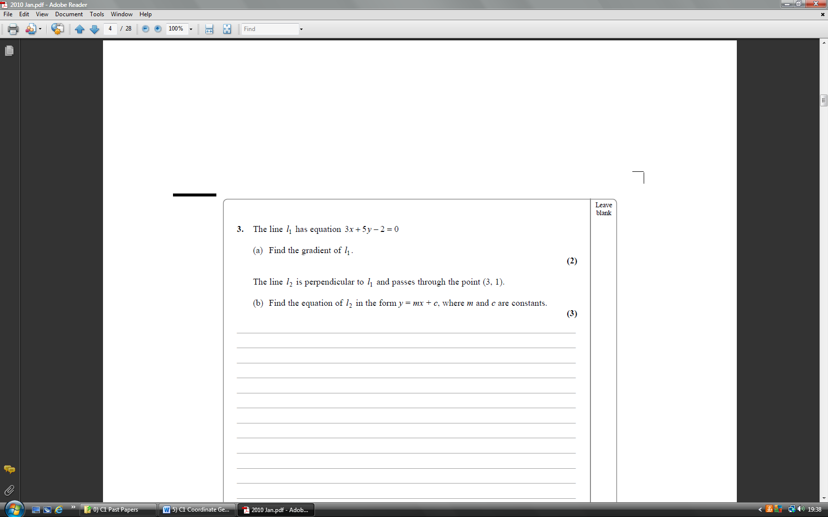

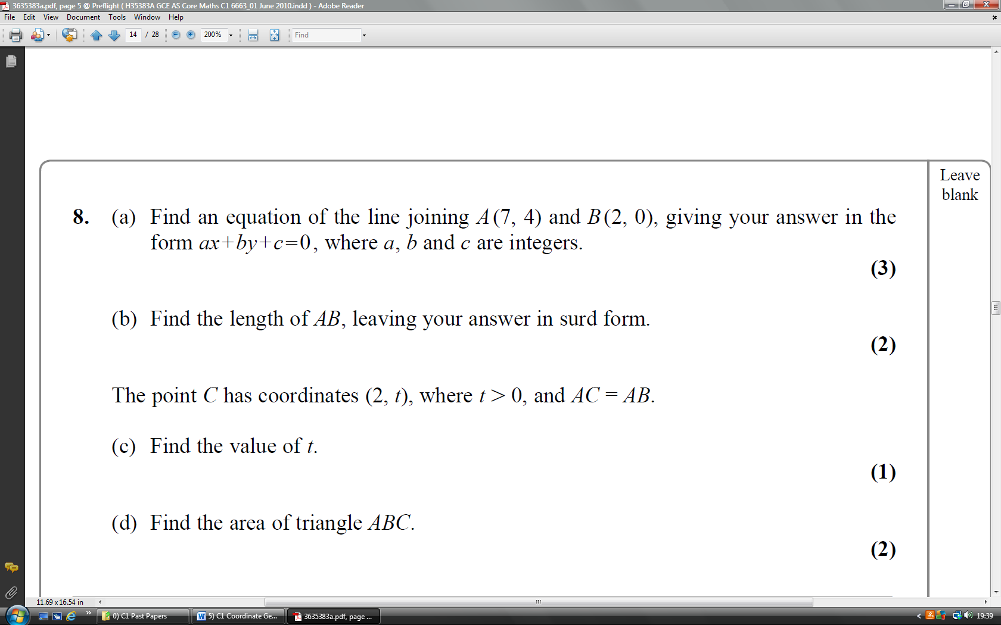

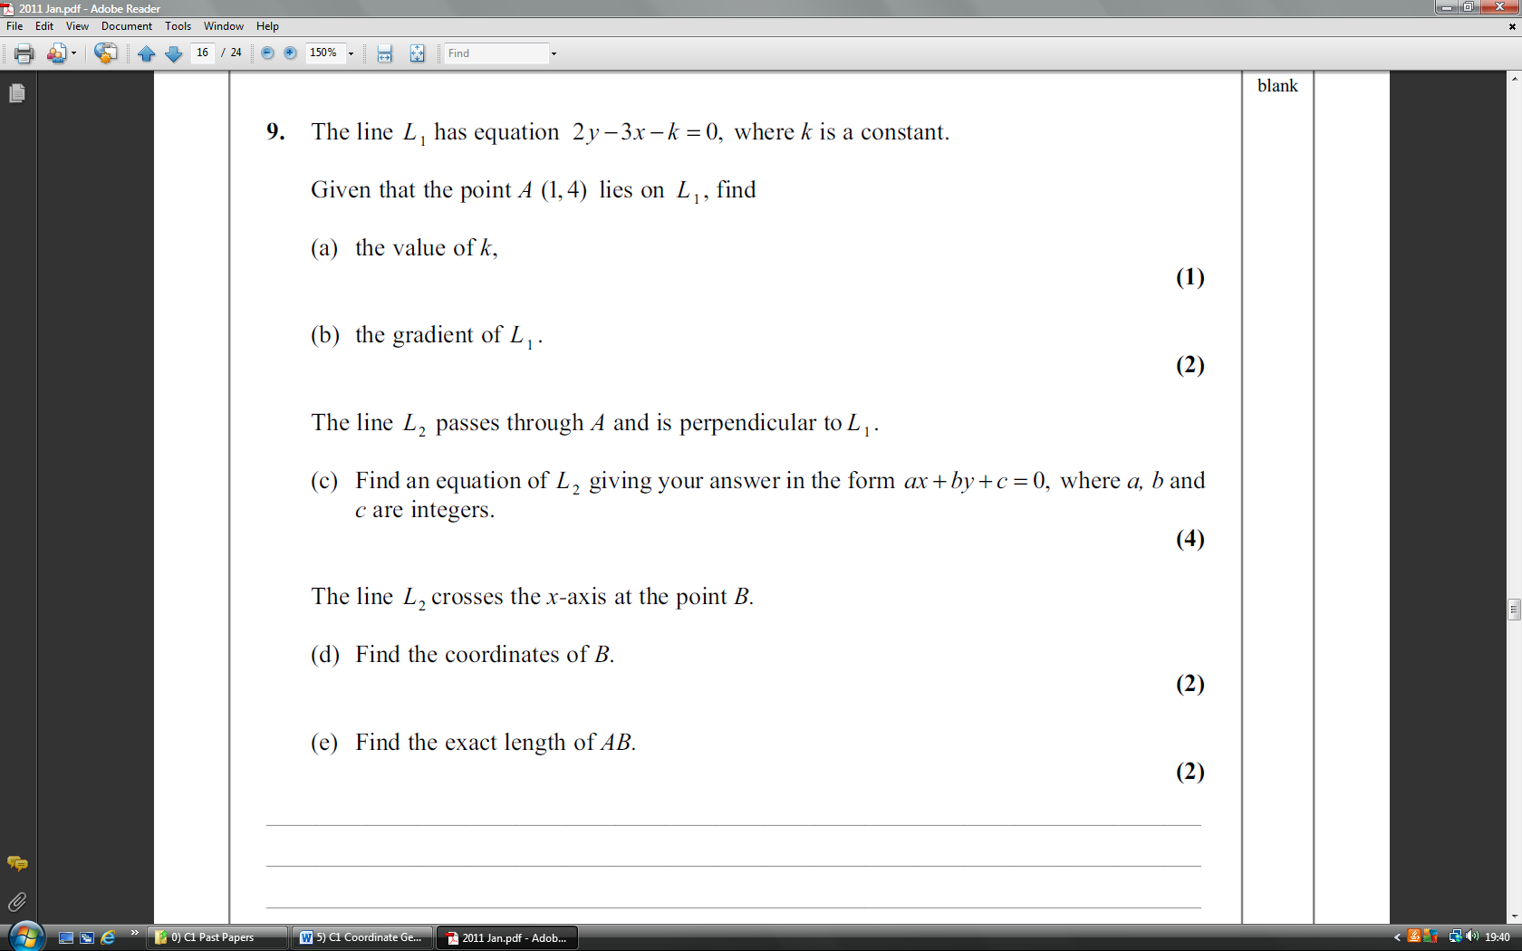

**C1 - Coordinate Geometry in the (x,y) plane Questions ANSWERS (63 marks)**

June 2006

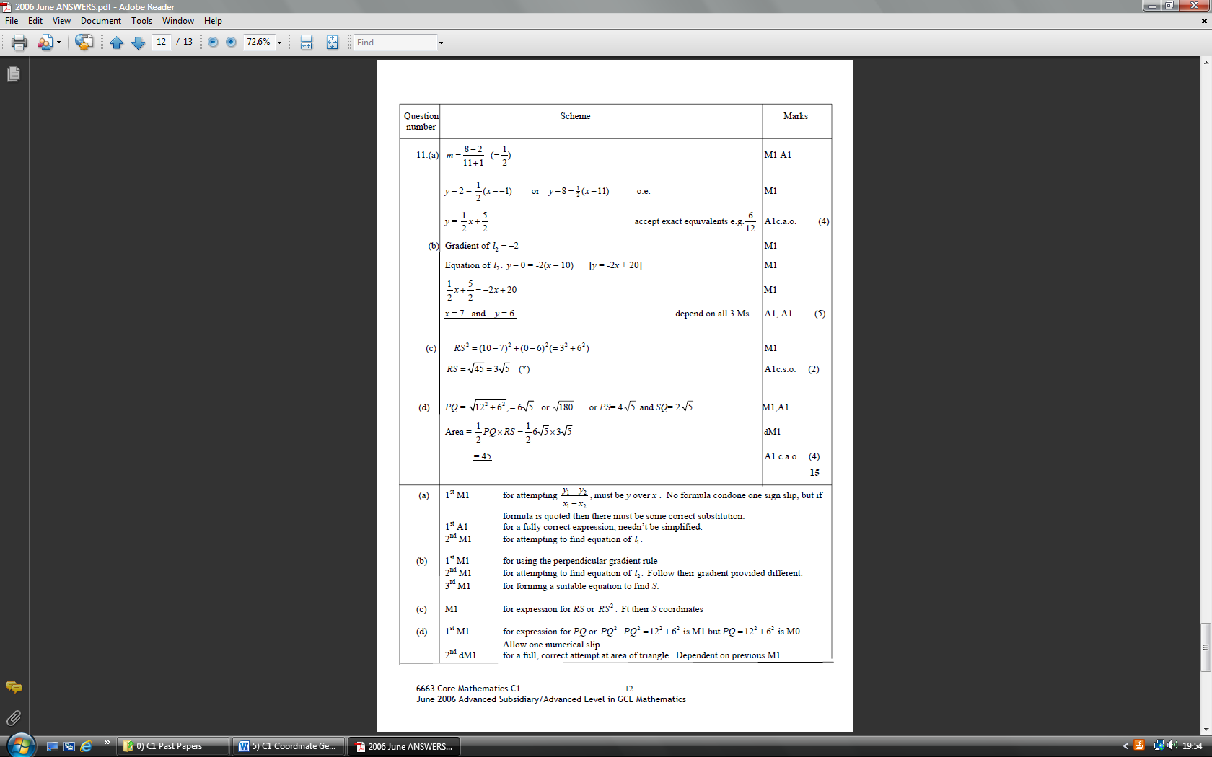

June 2007

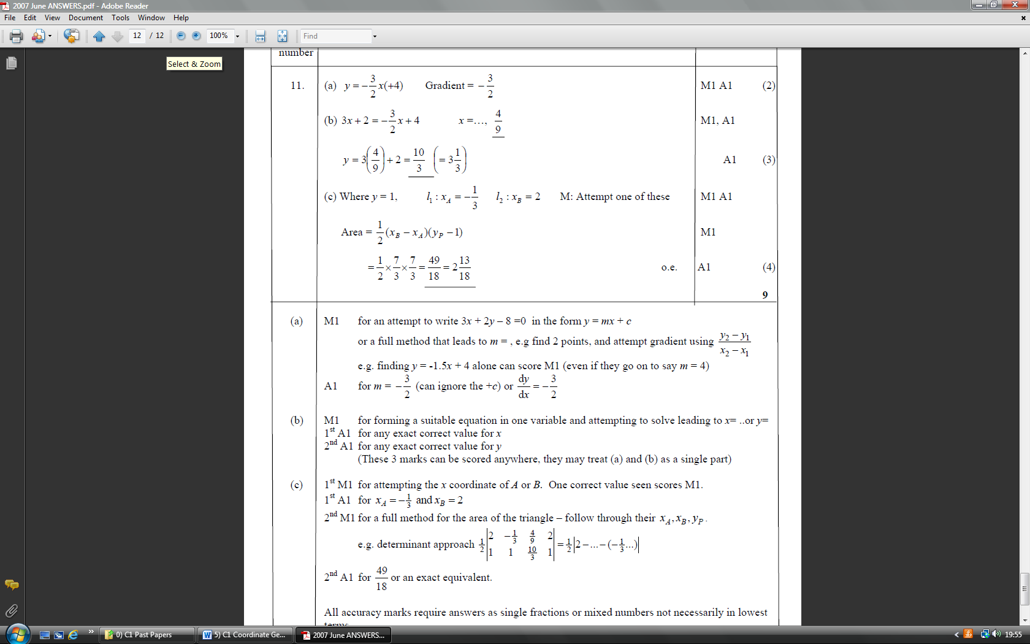

Jan 2008

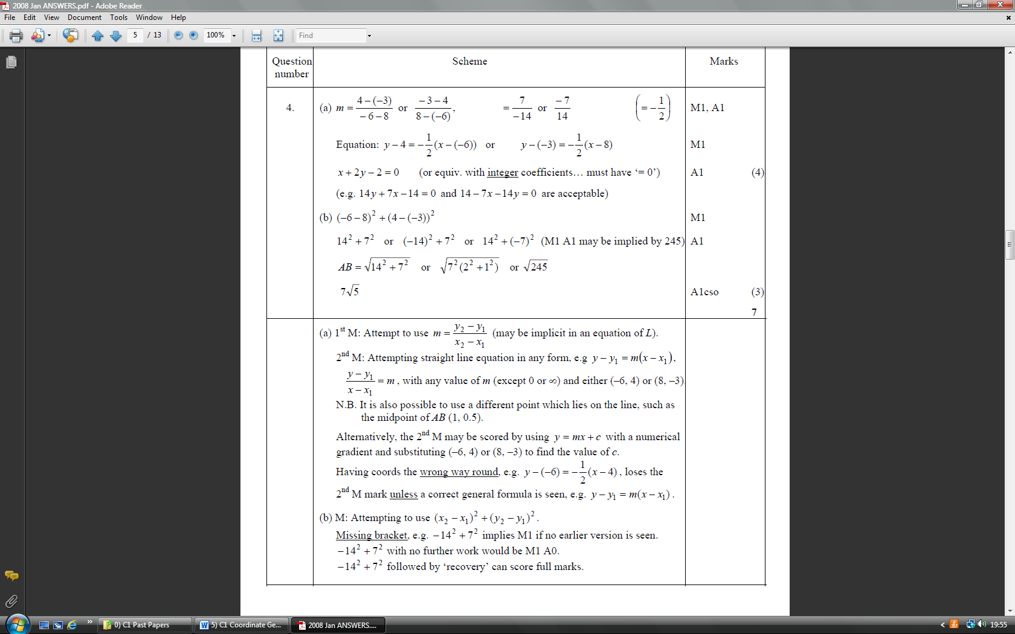

June 2009

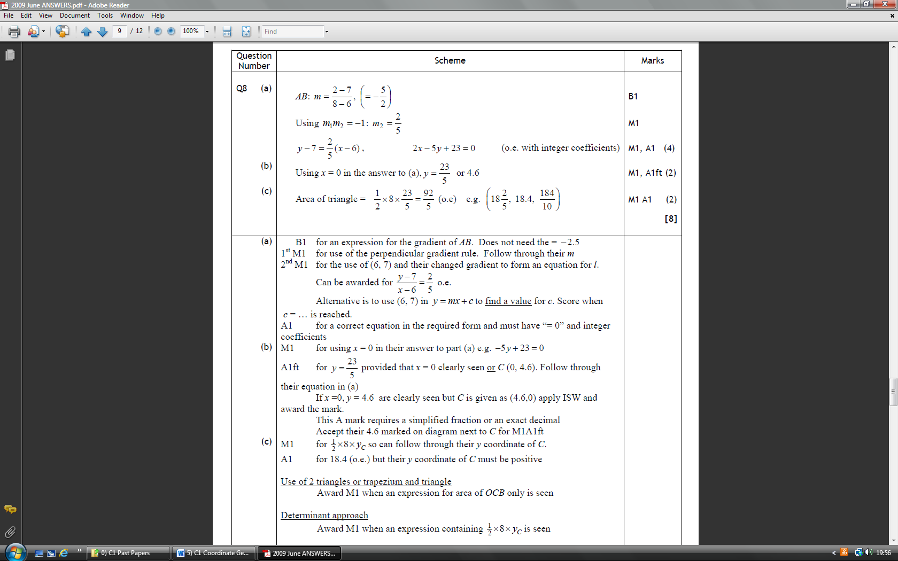

Jan 2010

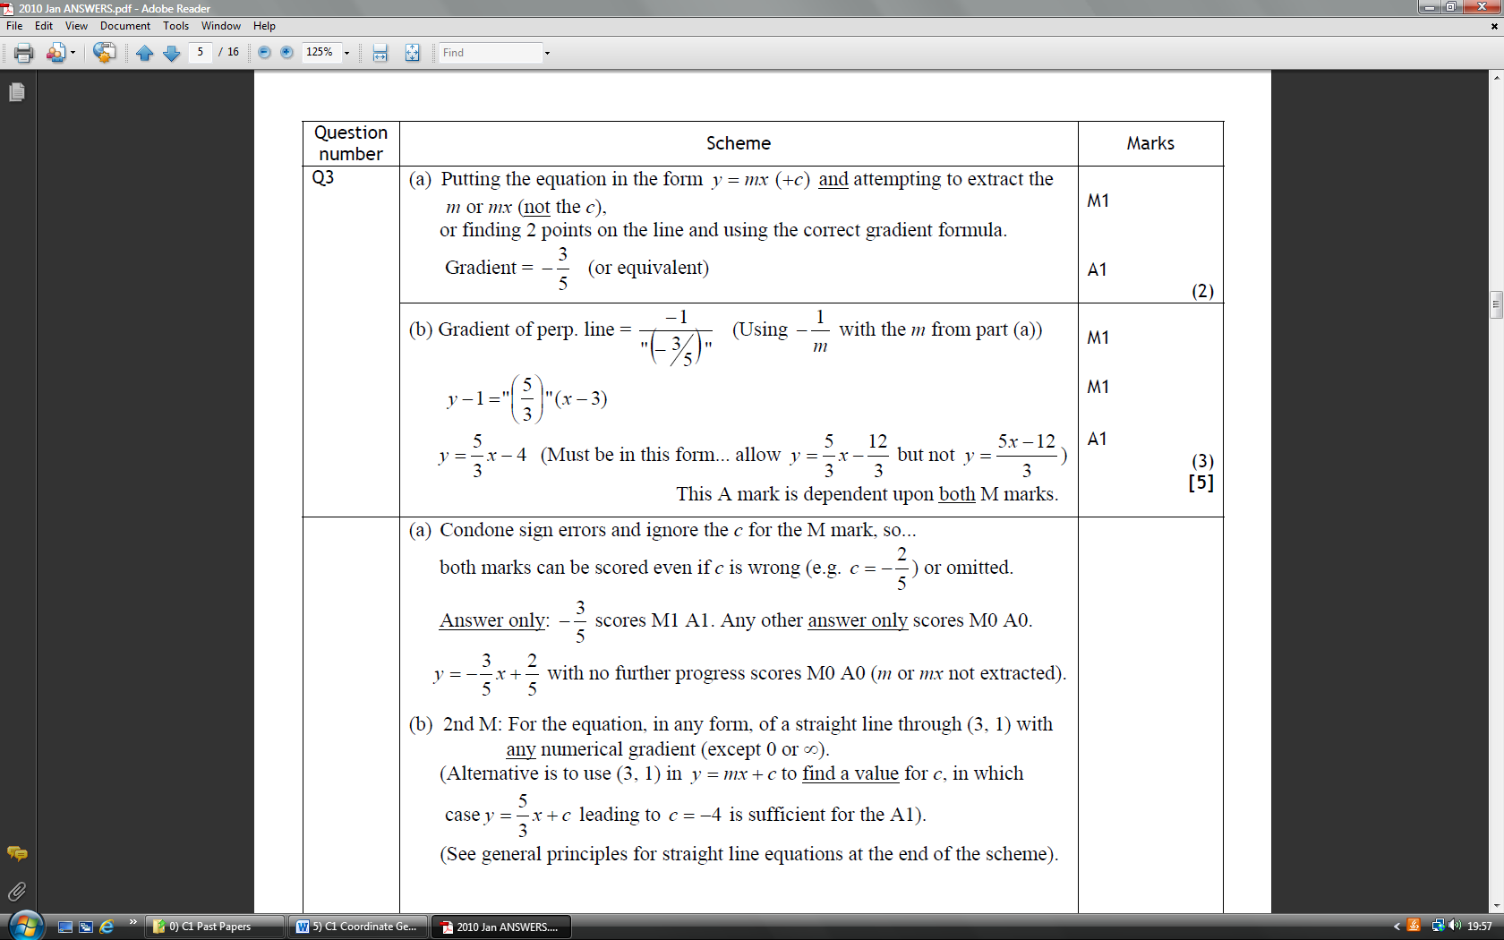

June 2010

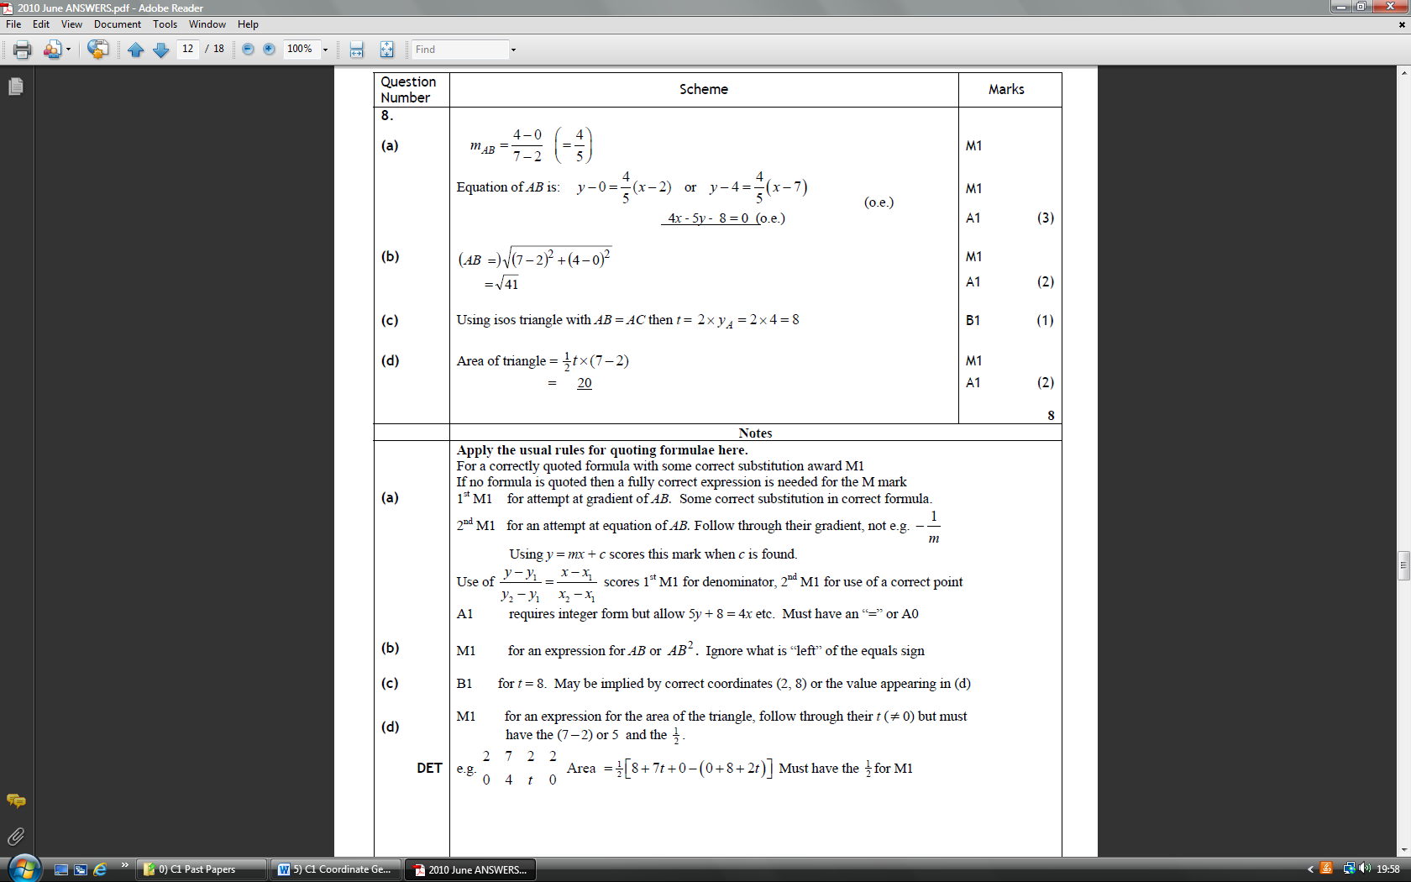

Jan 2011

