Fun on the Farm
Saturday saw Eloise and Niamh partake on a most excellent adventure to seek out and interview JB Gill on his farm for the BBC School Project taking place this year at Charles Darwin School. It was a day of high festivity and merriment, as hundreds flocked to get a glimpse of the former JLS star turned Turkey Farmer. The wait in line was arduous to say the least but totally worth it, as Eloise and Niamh were given ‘backstage’ access to the black taxi come photo booth JB was inside.
They posed a series of questions to JB; what made him choose turkey farming? How do you cope with the change? Does your wife participate and help on the farm? Each question was given ample time from the very generous farmer and time was taken to record his efforts.
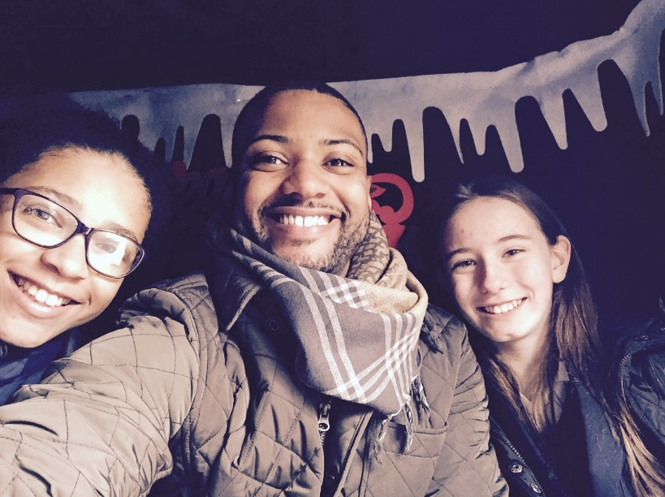
The cold winds and bitter, crisp air could not hide the delight of the two year 7 pupils as they emerged from the photo booth with autographs and a once in a lifetime experience. Further questions were posed to his father and mother before the samples of the day (turkey, sausage and hot Ribena) were taken.
All in all, it was a fabulous day for both students and something they will long remember!
By Eloise and Niamh.

