A-Level French

Overview
Studying a language at A Level takes you on a journey of discovery. You will deepen your knowledge, understanding and interest in the culture, history and future of France and French speaking countries.
You will become a fluent French speaker able to express yourself confidently on a number of topics and themes and grammar will come more naturally to you as you progress through year 12 into year 13.
In year 12 we will begin to study a film or book and this will enable you to deepen your knowledge of French culture from a literary point of view.
Visiting France and Belgium on one of our languages trips will allow you to use your French in a real context.
We will sit the AS exam internally at the end of Year 12.
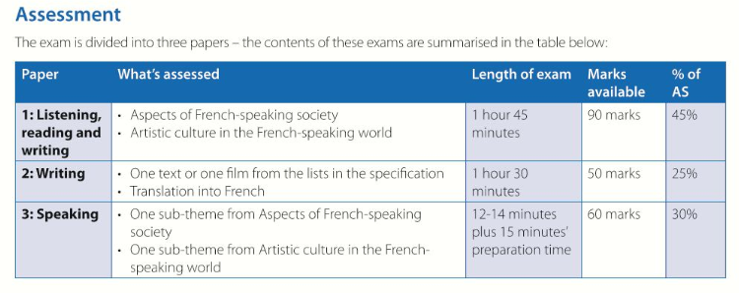

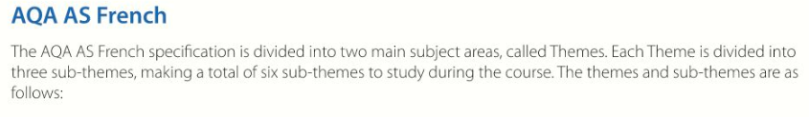
It would be a good idea to do some research on some of the following areas, that you are especially interested in by looking online and finding articles and YouTube clips. Make notes of vocabulary, phrases, facts and useful websites you have found and keep your notes well organised in a folder to bring in when we return to school

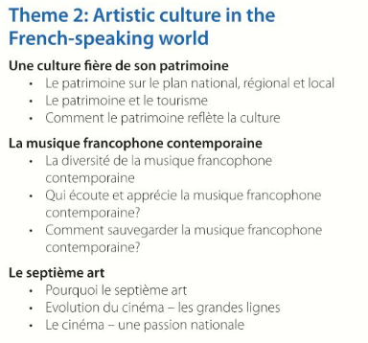
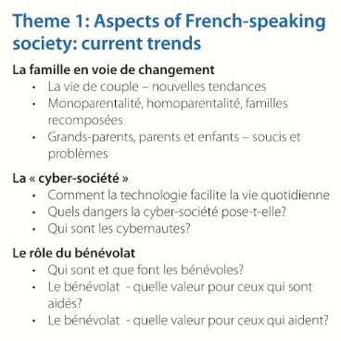

We will sit the AS exam internally so that you get used to the style of exam, but all official exams will be taken at the end of year 13.

