A LEVEL HISTORY:
Russia 1917-1953

BRIDGING THE GAP

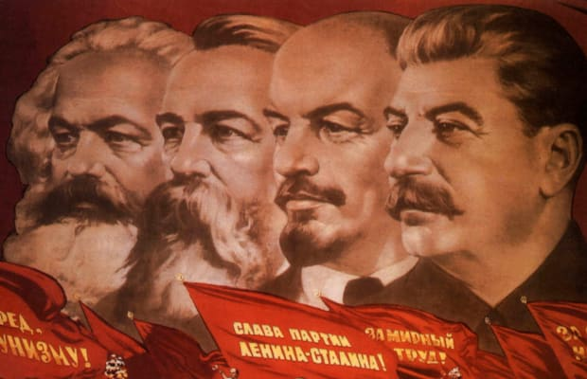

Section 1: Introduction to Russian History 1917-1953.

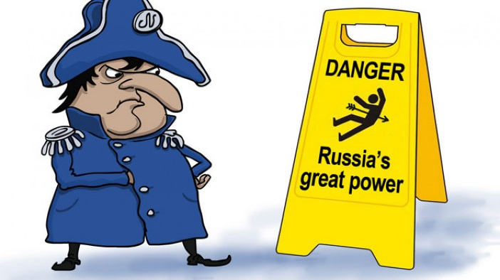
The end of the cold war in 1989 and the subsequent collapse of the Soviet Union might lead some to ask if the Russian Revolution and its aftermath is really worth studying. Fortunately such naïve questions can be quickly answered. You study Russia, not just to get an understanding of the events which occurred there, but to get an understanding of world history in the 20th century. The Russian Revolution did not just impact Russia, its impact was to dominate global politics for the next century and many would argue continues to do so. With the establishment of a Communist dictatorship, which was to result in famines, wars and a suffering on a scale rarely seen in world history, the fear that this experiment generated (and not just within the boundaries of Europe) determined the policies, both domestic and foreign, of so many nations. To understand the role that Russia plays in the world today, to understand the Second World War, to understand the Cold War, to appreciate why Putin is in power and to understand so much more of the world today, requires an appreciation of what happened in Russia.
In 1900 Russia was a vast, but disconnected and economically and politically backward nation. In 1953 it was an industrialised, nuclear superpower. To achieve this brought with it suffering on an unimaginable scale. By the end of this course, you will be asking yourself, ‘Can the ends ever justify the means?’ Hopefully you will also have an answer for this question. Revolution, Terror, Famine, Experiment, Conflict, Disaster, Murder, Totalitarianism, Industrialisation, Culture, Superpower, Megalomania – these are words that you will be associating with your history of Russia. Enjoy.

The key topics that you will be studying and examined in are (40% of your final total):

- The causes of the Russian Revolution in 1917
- How did the Bolsheviks consolidate their hold on power between 1918-1924
- Stalin’s rise to power 1924-1929
- Economy and society under Stalin 1929-1941
- Stalinism,, politics and control 1929-1942
- The Second World War and Stalin’s dictatorship 1941-1953

How do I understand the context of the course? Three tasks to complete.

- Find out about the origins of the First World War. You can go big and read Christopher Clarke’s outstanding book called ‘The Sleepwalkers’ or AJP Taylor’s slightly easier ‘The Causes of the First World War’. Make sure you are aware of both the long term and short term causes of the war, the role of particular nations and the importance of nationalism, militarism and imperialism.
https://www.youtube.com/watch?v=rfvO2aX6ddA This link provides a brief but pleasing over view of why the war broke out.
Write a couple of pages on the causes of WWI. Have a particular emphasis on the role of Russia in this.

- What was Russia like before the First World War? To understand this you need to look at the key event of the 1905 Revolution in Russia. https://www.youtube.com/watch?v=CLCPZddsUWs This is a short video about Bloody Sunday – the key event of the 1905 Revolution
https://www.youtube.com/watch?v=ALGi1yf3YYI Use this link (the narrator does have a strong accent but it is good) to consider the causes and consequences of the 1905 revolution. Write a couple of pages on the causes and consequences of the 1905 Revolution. Make sure you consider economic and political issues in particular – you will probably need to do some of your own research on this topic too.

- Also look at the state of Russia before 1917 and in particular the nature of the Russian Empire:
Produce an overview in the form of a powerpoint on the nature of the Russian Empire in 1914. Use the following headings to structure your work:
• Nationalities
• Geographic extent
• Industrial and mining areas
• Key cities
• Key rivers
• Important agricultural areas
• Information on who controlled the wealth and resources of Russia
• The social structure of Russian society
• The Nobility and the Orthodox Church

An outstanding book to use is Orlando Figges ‘A people’s Tragedy’ which has a number of chapters on the social, political and economic status of Russia at the turn of the 20th Century. It is a large book, but good to read. Just read Part 1 to help you with much of the above.
https://www.youtube.com/watch?v=t1b3f2UykG0 – this links considers the state of Russia before the First World War.

Films to Watch
Possible Films you might watch (and enjoy) on this period of history:
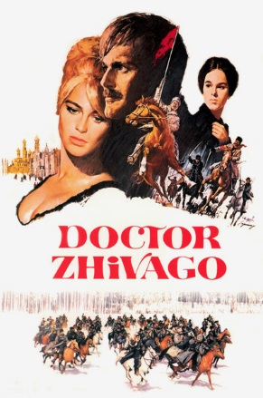
Doctor (find it on clickview) – one of the epics of the cinema. You must watch the David Lean version however, made in 1965, it is perfect escapism. Filmed in Finland because the Soviet authorities would not allow it be filmed in the Soviet Union. It is set in the context of the Revolution and subsequent civil war and is based on the novel by Boris Pasternik. If you want to impress your friends (and your teacher) you might actually read the book. Watch the film first and then the book as it is a challenging novel and having some understanding of the story in advance will help you. The book was banned in the Soviet Union for years although its author won the Nobel Prize for literature.
Child 44 – I mention the book below which is brilliant. A film was also made of the book which makes for interesting viewing. On this occasion read the book first is my suggestion
The Death of Stalin (find it on clickview) – a black comedy about the days following the death of Stalin. Shows just how much power Stalin had over his political allies, even after he had died. Funny and enlightening at the same time.
Nicholas and Alexandra – although as much fiction as fact, it does give you a taste of Tsar Nicholas II, the inept last monarch of Russia, who is insensitive to the needs of his people, is overthrown and exiled to Siberia with his family.
Enemy at the Gates – In Year 13 you will be studying WWII and its impact on the Soviet Union. This film, which is brilliant fun to watch, tells the story of two snipers (Soviet and German) and their life and work during the Battle for Stalingrad.
One Day in the Life of Ivan Denisovich – based on the remarkable book by Alexander Solzhenitsyn who himself was in the Soviet Gulag (prison camps). Tells the story of a single day of Ivan Denisovich. It is worth reading the book (not a big book!) to get a true picture of what life was like in the prison system under Stalin
Two other good films – not relevant to the course at all but set in the Soviet Union and so of periphery interest are the Hunt for Red October and Gorky Park. Trust me when I say that they are good films!
A series of documentaries to watch which will really provide an excellent introduction to the whole course is ‘The Last Czar’ which is a a 6 part series with historians' comments. You can find this on Netflix. The following link is documentary called ‘Last of the Tsars - Nicholas II & Alexandra’ – Do watch this. It is very good and focuses on the end of the Romanov empire. I would like you to take notes on this as evidence that you have watched the documentary…. https://www.youtube.com/watch?v=QpWyFcH-1tE

Reading to consider
Some choice novels to engage you with Russian history. All of them come highly recommended and will help draw you into the study of the Stalinist period:
1. The Innocent by David Szalay. It is 1948 and a major in the KGB is sent to an isolated psychiatric clinic to investigate one of the patients there long presumed dead. 24 years later the man is still haunted by the case and his Stalinist faith under threat
2. Child 44 by Tom Rob Smith. 1953 in Stalinist Russia and a Police Officer is investigating the death of a young boy. As the truth unfolds, the once utterly loyal Police Officer starts to risk everything and becomes an enemy of the state in order to get to the truth. A page turning read
3. One Night in Winter by Simon Sebag Montefiore. Starting with the murder of an important official in Post War Stalinist Soviet Union, this is a gripping tale which plays out at the very top of the Communist Party and shows just how much power Stalin was able to wield. An excellent read. He also wrote Sashenka – a book set around the Revolution itself. Again a great read.
4. Archangel by Robert Harris. Archangel is a remarkably literate novel and simultaneously a gripping thriller that explores the lingering presence of Stalin amidst the corruption of modern-day Russia. Robert Harris elevates his tale by choosing a narrator with an outsider's perspective but an insider's knowledge of Soviet history. Fantastic fun!
The Whisperers by Orlando Figes: Not a novel but an oral history on the whole period. An astounding history book showing the impact the revolution had on ordinary people in Russia. Brilliant!

Specific history books you might want to consider trying to read are:
Robert Service: One of the best and most knowledgeable in the field of Russian history. Has written biographies on Stalin, Lenin and Trotsky and his most recent book ‘The Last of the Tsars’ deals with the reign of Nicholas II and in particular the months before he was executed. All books are terrific.
Orlando Figges: Above is mentioned The Whisperers, which is one of my favourite history books on any topic. He has also written ‘A People’s Tragedy’ which is huge, but highly recommended. You will not read the whole book at once – you will dip in and out of this book as and when you need to.
Simon Sebag Montefiore: He has written some great novels (see above) and also a book called ‘The Court of the Red Tsar’. This is about Stalin the man and shines a light on many aspects of his erratic, brutal and terrifying behaviour. Recommended

Useful skills for further education
Taking notes at A-level
During classes and for home learning you will be expected to take notes on a broad range of topics and case studies, therefore it is important that you arrange and structure these notes in a way that is both informative and easy to revise from when required. The more organised you are with your note taking the easier your revision will be.
To help you with note taking at A-level below are some different note taking and revision strategies that you should be familiarising yourselves with. Not every format will work for you but it is important that you establish good practice. Notes are not about writing down everything they are about recording the key information. As you go through the resources above try some of the different note taking strategies below:

1. The outline method:
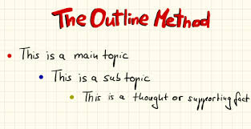
One of the best and most popular methods, it lets you organise notes in a structured form and break up different topics and their subtopics. Main topics go on the far left and add subtopics below using indents.
Pros:
- Highlights points in a logical way
- Reduces reviewing and editing time
- Gives a clear structure.
Cons:
- Doesn’t work well if the lesson or resource jumps between topics.
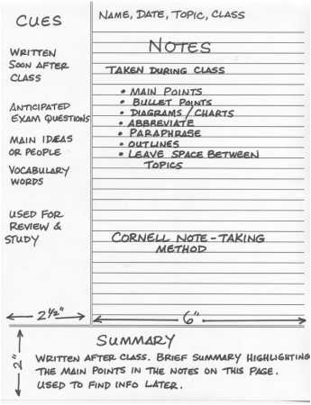
2. The Cornell Note:
http://lsc.cornell.edu/study-skills/cornell-note-taking-system/
One you may be familiar with from GCSE. A very structured form of note taking with a clear page layout, all the main notes from class go in the main note taking section, the small left hand column is for main topics or questions, and the section at the bottom allows you to summarise your learning.
Pros:
- A quick way to organise and review notes
- Very systematic
- Cuts down reviewing time
Cons:
- Requires preparation beforehand
- Needs time for reviewing and summarising after the lesson.

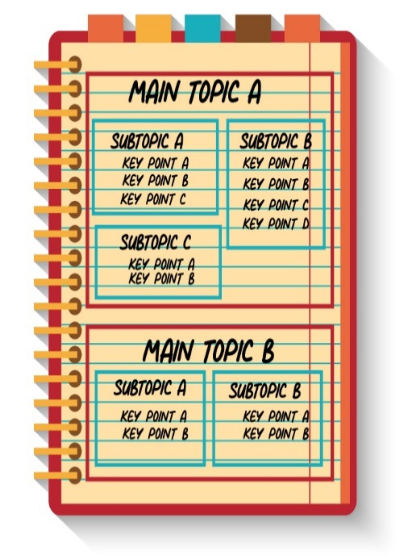
3. The Boxing Method:
A less common method but becoming more popular. A dedicated box is assigned for each section of notes, with smaller boxes used for each sub section. Best used when doing digital notes but can still be used for hand written work or when reviewing notes from a lesson.
Pros:
- Segregates and organises information
- Allows you to focus on one box at a time when revising
Cons:
- Not east to do during a live lesson
- Doesn’t work well if no overall topics can be assigned to groups.

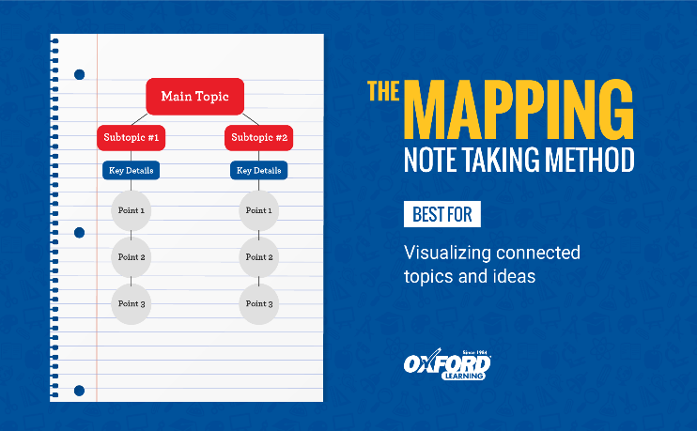
4.The Mapping Method:
Mind mapping is one of the most common forms of note taking, and is best used when there is a large amount of content around a topic, for instance tectonics has a large number of volcanic and seismic case studies. Mind mapping is also useful to show the relationships and links between different sub topics.
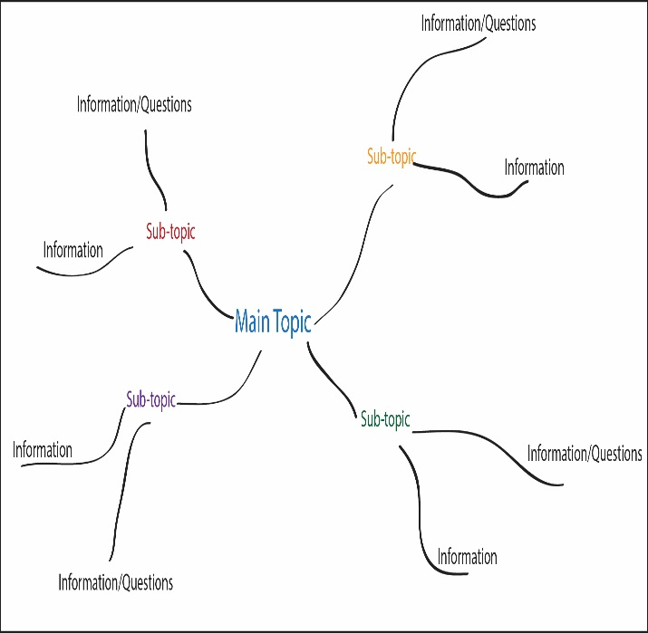
There are two types of mind mapping you can use, a traditional mind map (spider diagram) or a flow line map.
A traditional mind map is excellent for breaking down large case studies or key ideas, whilst a flow line map is an excellent visual way of outlining geographic processes.
Pros:
- Visually appealing
- Detailed information in a concise form
- Easy editing of notes
Cons:
- Can run out of space if notes are too detailed
- Can be time consuming to create.

There is no definitive way to take notes and you will naturally fall into a structure that is natural for you during lessons.

