Welcome to
Teachers: Mrs S. Mears – sme@cdarwin.com and Mrs Quinn- GQu@cdarwin.com
Preparation assignment for A-Level Sociology - Summer 2022
As you have not studied GCSE Sociology we’d like to help you get prepared for A-level with an assignment that is set for you to do three things;
- To get you up to speed with core concepts occurring throughout the A-level units.
- To encourage your sociological world-view
- To give your teacher a sense of your commitment to this A-level.
Having said that – it is not a test or anything requiring essays! This is an opportunity to find out about key sociological ideas so that you will be able to proceed with the A-level with more confidence. It is not an assessment!
Course Materials- If you take Sociology it is advantageous to have your own textbook to use- this means you don’t have to share a book in class and you can take it home to use for essays. The book I recommend for year 12 is below, (there is a different book for year 13).

AQA A Level Sociology For A level Year 1 and AS
Author: David Bown and Laura Poutney
ISBN: 978-1-4718-3939-9

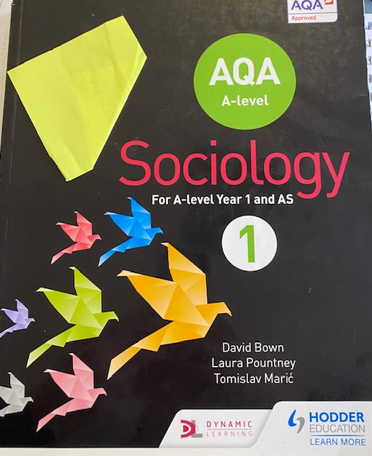
Please remember, if you are eligible, you can apply for a bursary to cover the cost of books.
At the Heart of Sociology are three questions:
What is happening in society? (Social Research – overlaps with geography, Politics, Psychology and Maths)
Why is it happening? (Social Theory – overlaps with Politics, History and Philosophy)
What can be done about it? (Social Policy – overlaps with Politics)
Note: You do not need to print this booklet to do the work; however you might want to print it when you return to school and staple your answers to it. You may type or handwrite your answers to the tasks.
What is sociology?
Sociology is the study of how people’s lives are affected as a result of belonging to different social groups. We all belong to social groups. The main groups studied are:
- Social class
- Age group
- Gender
- Ethnicity
Sociology is a social science, studied by sociologists.
This means sociologists conduct research to find factual evidence and patterns about how different groups in society behave. For example, how the recent coronavirus epidemic affected people differently if they were middle or working class. Are women more likely to choose to not to marry than men?
Sociologists come up with ideas – theories – to try and explain these patterns of behaviour. Also, they do research to try and find evidence that backs-up their theories.
This means that as sociologists we are not giving our opinion of what we think should or should not be happening in society or whether it is fair or unfair – we are understanding, analysing and evaluating the evidence and the theories.
Core Concepts
Sociological theories are usually of two types:
- Social processes - the behaviour of people in different groups is the result of what they have learned from family, school, peer groups, media etc.

- Social structure - the behaviour of people in different groups is the result of how society is organised and the position of groups in society.
The study of sociology has core concepts – important basic ideas – that relate to both social processes and social structure. These core concepts have to be known and understood in order to make sense of and discuss the research evidence and theories of sociologists.
Important core concepts:
- Culture
- Socialisation
- Social Class
- Gender
- Ethnicity
- Sociological perspectives

Possible Sociology revision / education sites to explore for research and help include:
https://www.tutor2u.net/sociology
https://revisesociology.com/
https://sociologytwynham.com/
https://www.youtube.com/channel/UC6VpoZj33Df_rNb8KymCczw
Tasks:
- A) - Introduction – What is Sociology
We will start the course by exploring what actually IS Sociology? It is defined as the ‘study of society, people and behaviour’ but what does that mean? To help do this, watch these clips and make some notes of why you think it is relevant.
Video Clip – if the hyperlink doesn’t work copy and paste into a new browser window. | Notes – Use the statements to help you phrase your response: | Some statements to help you make notes:
Clip 1 – Watch this 5 minute video about ‘What is Sociology’ https://youtu.be/LK5J0-cM-HE |  | Whilst you watch it is useful to analyse, and this can be done through statements such as:  ✓ I noticed…  ✓ I have realised…  ✓ I was surprised …  ✓ I begin to  understand…  ✓ I Love the way…  ✓ I am not sure  about…  ✓ A question I have…  The last one is very important as you will not always have the answers BUT you can always ASK QUESTIONS!
Clip 2 – Watch this 5 minute video from the London School Of Economics explaining why Sociology is essential from a University perspective. https://youtu.be/7ZJlFxDavpc

Clip 3 – Watch this 3 minute clip about gender made by Always called #likeagirl https://youtu.be/XjJQBjWYDTs

Clip 4 – Watch this 4 minute clip about privilege and inequality called ‘Life of Privilege Explained in a $100 Race’ https://youtu.be/4K5fbQ1-zps

Task 1B
Each group of statements represents a sociological theory or viewpoint. Say which ONE statement out of each group you agree with and give reasons why you have chosen it.
Group A Statements:
- Men dominate.
- Gender inequalities exist.
- Women are systematically disadvantaged.
- All men hate women some of the time. Some men hate women all of the time.
- Women are those that are depending on all of the time for all of the tasks.
I agree with ……………………………………………………………………………………………………………………………………
……………………………………………………………………………………………………………………………………………………….
……………………………………………………………………………………………………………………………………………………….
Group B Statements:
- Society exists in a state of balance.
- Society works for the benefit of all.
- Structures in society exist to help people and the smooth operation of society.
- We live in a democracy.
- People are judged only in terms of their merit / skills / intelligence.
I agree with ……………………………………………………………………………………………………………………………………….
…………………………………………………………………………………………………………………………………………………………..
…………………………………………………………………………………………………………………………………………………………..
Group C Statements:
- Life is unfair.
- People are not paid enough.
- The world is run for a very small group of people.
- Most people cannot see that they spend their entire lives being exploited.
- Our current system for organising the economy does not work.
I agree with ……………………………………………………………………………………………………………………………………….
…………………………………………………………………………………………………………………………………………………………..
………………………………………………………………………………………………………………………………………………………….…

Challenge: Can you ascribe the following sociological theories to each group of statements above? Annotate above.
Marxism, Feminism and Functionalism.
Culture
Q2) Explain what is meant by CULTURE

Norms: behaviour that is expected in situations, Examples: eating with a knife and fork, saying ‘thank you’, sending children to school.
Values: principles or goals that are seen as good in that culture (e.g. honesty; hard work).
Q3) Make a list of three things that you think are part of ‘British’ culture:

Q4) Give two norms of behaviour connected to Christmas:

Culture
In larger, more complex societies, such as 21st century UK, there may be different smaller groups that have their own set of norms and values. These are known as Subcultures.
Q5) Give one example of a subculture and the norms and values it might have that are different from mainstream culture:

Q6) To help you understand what a culture is, research a culture of your choice, but NOT British or American. Use this as an opportunity to find out about another country that you know very little about. Record your findings in the table below
Laws | Dress | Food
Festivals and celebrations | Religion | Language
Sport | Traditions | Family Life

Socialisation
Q7) What is meant by socialisation?

There are two types of socialisation:
- Primary socialisation
- Secondary socialisation
Primary socialisation takes place in the early years – mainly within the family.
Secondary socialisation takes place later in wider society – such as in school, with peer groups, the media or in the work-place.
Q8) Make a list of three ways of behaving that family would usually socialise their children to have:

Q9) Make a list of one norm or value that people may be socialised to have that could be learnt from:
- School:

- Teenage peer-group:

- Media:

Socialisation is reinforced by the use of sanctions. These may be applied by parents, schools, the workplace or the legal system.
Q10) What do sociologists mean by sanctions?

Q11) Give an example of a positive sanction that could be used by family with a young child as part of primary socialisation:

Q12) Give an example of a negative sanction used as part of secondary socialisation:

Social Class
In the UK people belong to a social class although they may not know it; although it is slightly more complicated than the list below the crude assumptions made by the media and society are that people belong to the following social classes:
- Working class - low skilled or skilled manual work (eg cleaner / plumber)
- Middle class - highly trained ‘professions’ (eg doctor / lawyer)
- Upper class - often inherited wealth, those with no need to ‘work’.
The majority of people are either working or middle class. Some researchers argue that class no longer exists, but the idea of social class is used by many and they nearly all agree that the class a person belongs to can affect their life-chances
These days official documents and organisations aim to base someone’s social class on their education, job, level of responsibility and status – not just income and job; this has meant an increase in the number of classes - we will cover this in class in September.
Q13) Read the following evidence statements and decide whether you think they apply to either working class or middle class.
Evidence | Middle | working
Most likely to value education
Most likely to go to university
Most likely to have low incomes
Most likely to turn to crime
Most likely to live in deprived areas
Most likely to have important careers (journalist / judge)
Most likely to be privately educated
Gender
A person’s gender is their biological sex as male or female (or what they choose to identify as). Sociology focuses on the roles and norms that are expected of people as a result of their gender. Sociologists consider the norms and roles expected of males and females to be a social construct – a set of ideas that do not exist in nature but has been created by society.
Q14) List three types of behaviour that families socialise girls to have:

Q15) List three types of behaviour that families socialise boys to have:

Q16) Give two ways schools have expectations of boys that is different from girls:

Ethnicity
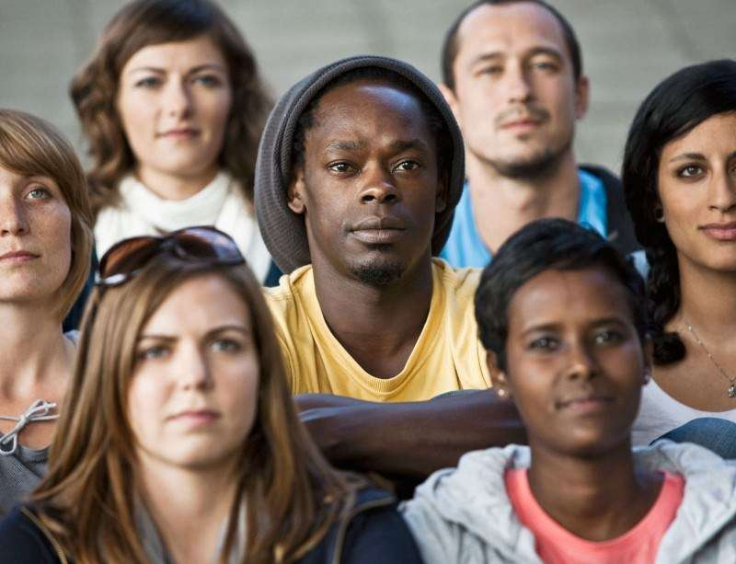
Q17) Ethnicity is NOT race or skin colour. What does ethnicity mean in Sociology?

Q18) Britain is a multicultural society. What does this mean? Use examples if you can.

Q19) White British is the ethnic majority. What are two of the largest ethnic minority groups in the UK?

Sociological Perspectives – This might be more challenging but it is expected that you know this to access A level Sociology.
Some sociologists seek to explain society by looking at how it is structured. These views of society are called sociological perspectives; the main perspectives are:
- Functionalism
- Marxism
- Feminism

To help with the questions below you could use the following websites-
- https://revisesociology.com/2016/07/05/sociological-perspectives-the-basics/
- https://www.youtube.com/watch?v=-83vVeSC2_g
- https://sociologytwynham.com/2013/06/28/social-theory/ (also has some video links on it to make this easier).
- https://revisesociology.com/2017/02/03/feminist-theory-summary-sociology/
- https://www.youtube.com/watch?v=fSQgCy_iIcc
- https://www.youtube.com/watch?v=D6Dl-9pSW-4

Functionalism - Functionalism sees social structure or the organisation of society as more important than the individual. Functionalism is a top down theory. Individuals are born into society and become the product of all the social influences around them as they are socialised by various institutions such as the family, education, media and religion. A founding father of Functionalism is Emile Durkheim.
Q20) How do functionalists see society?

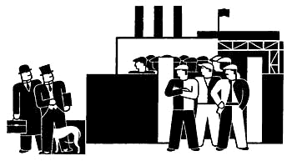
According to Marxists society is divided into just two classes that are in conflict:
- the bourgeoisie – The wealthy upper classes who own the businesses and means of production.
- the proletariat – the workers and employees of the bourgeoisie.

Q21) a) Explain why Marxists believe these two groups are in conflict:

B ) In your opinion is Marxism a useful theory in the 21st Century?

Feminism causes great confusion and misunderstandings in society. In Sociology we look at it from 2 ways – it is a social movement that advocates for economic, political, and social equality between women and men and as a theoretical perspective debating if women are uniquely and systematically oppressed in different societies and situations.
Q22) There are many different Feminist groups; from your research identify some of them and note the basic aims of Feminism.
- Types of Feminism:

- Basic aims of Feminism.

Task 23
Your next task is designed to challenge you, in this section you will find an article that is aimed at A-level students.

This article does use challenging words and may be difficult to understand at first so remember to take your time.

- Exploring the family!
The first article is Why Marry? It starts on the next page.
Produce a spider diagram/ table/ notes of the possible reasons why a person will marry. THEN in a different colour pen, can you think of reasons why they might choose NOT to get married? Add them both in the space below.

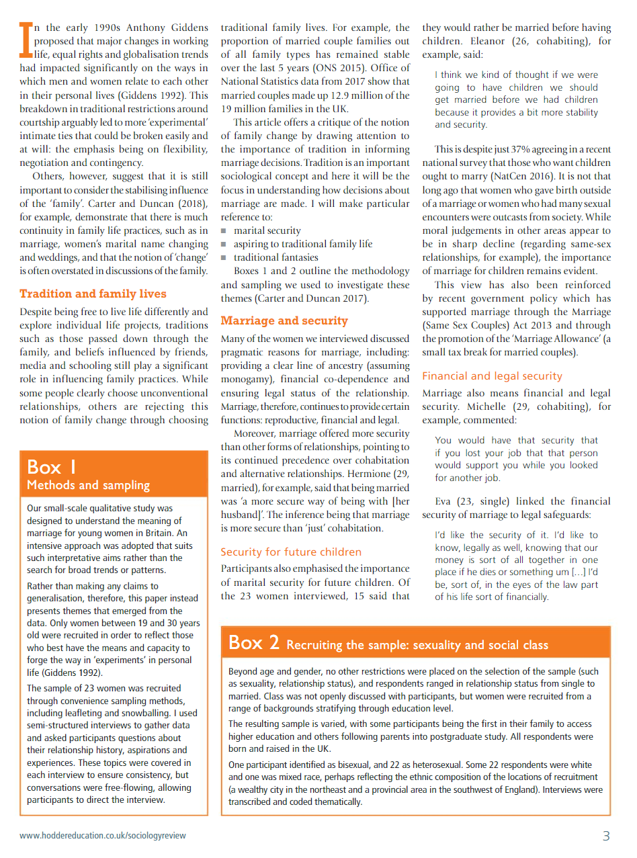

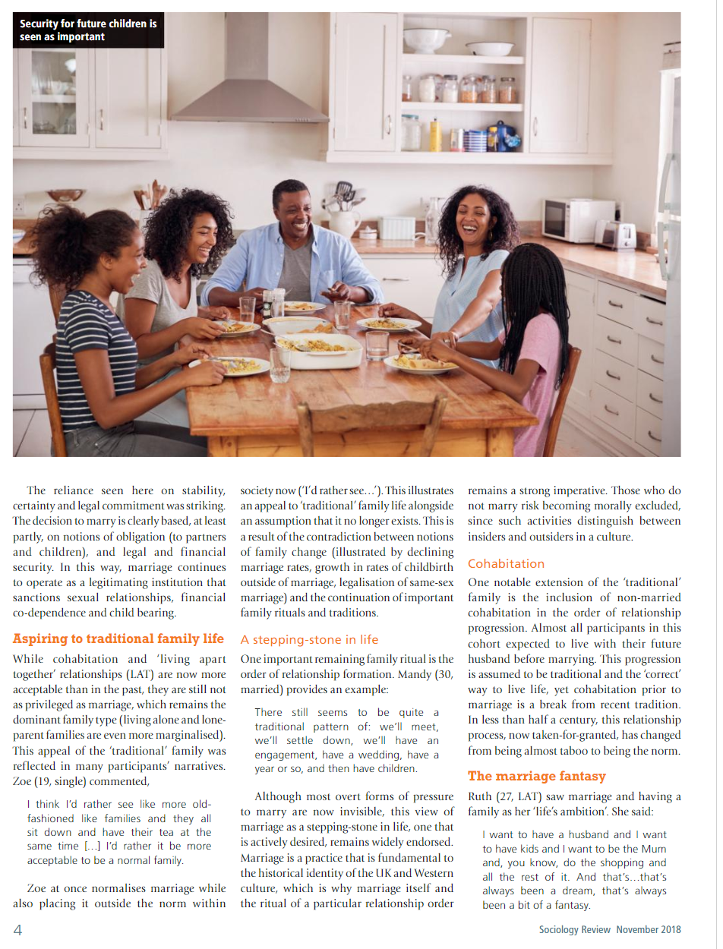
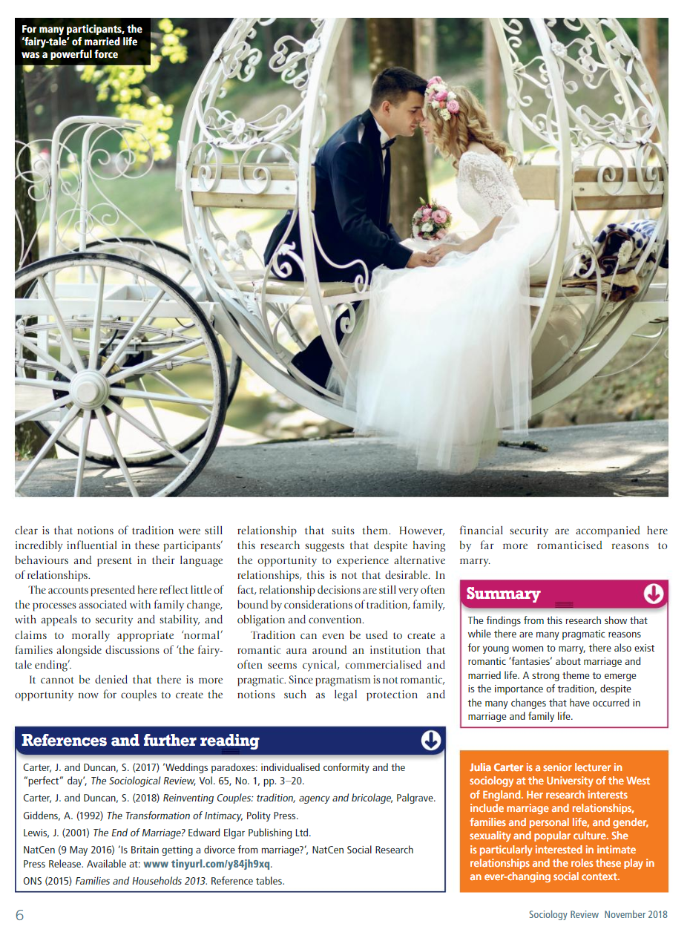
See the next page for the last task

Task 24 - Key Words
As part of the introductory task in the summer term you were asked to find out meanings of key words so for this task you may not need to find out all of them, only the ones that are new.
You may want to use the following website to help - (http://higheredbcs.wiley.com/legacy/college/browne/0745691307/glossary/student-resources-glossary_a1.html)
Remember if you are using google to ensure you understand the meaning and write it in your own words.
Key term | Meaning
Bourgeoisie

Capitalism

Confluent love

Discrimination
Feminism

Institutional racism
Marxism

Patriarchy

Postmodernism

Proletariat

Racism
Social Class
Social consensus

Social Control
Social Institutions
Status

