A Level Politics Year 11 Bridging work

Welcome Year 11 below are some bridging tasks to give you a flavour of what Politics is like at A Level. Hope to see you in September.
Mrs Ruth

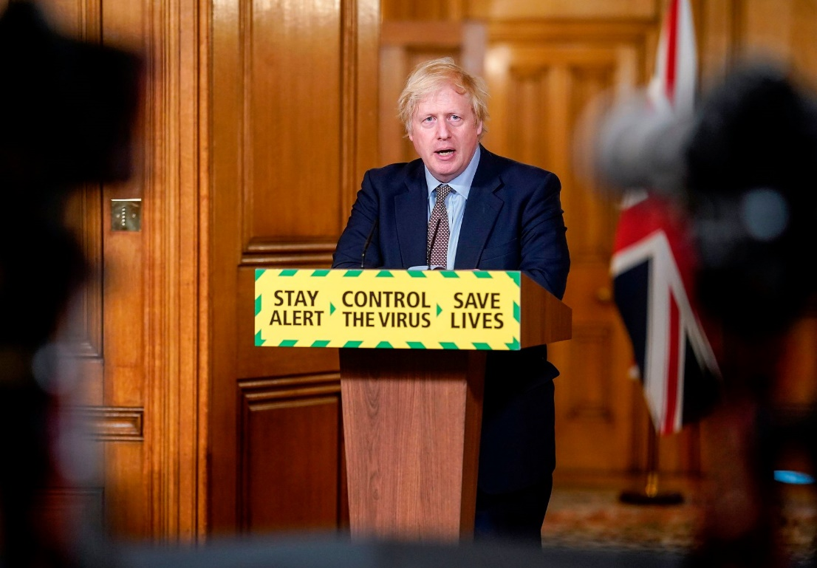

What is Politics?
“Politics is the study of how a people, a nation or a state is governed.”
When most people think of politics, they think of old, wealthy men (only sometimes women, and only sometimes ethnic minorities) in offices, making deals and agreements that will affect millions of people, just for personal gain. And it’s true that some decisions are made that way, but politics is much more than that.
Politics is about power, about people, equality, war, conflict, debate, cooperation, freedom, money, etc. – it’s about the relationship between the state (the government) and its citizens, or the state and other states. It governs everything we can and will do in our lives.
One of the reasons politics is so exciting is that it changes every single day based on the actions of individuals. Less than 500 people (in a country of 330 million) decided the result of the 2000 presidential election that made George Bush president. In 2001 he invaded Afghanistan and in 2003 he invaded Iraq. These two things have changed the Middle East and global politics, perhaps forever. Closer to home, if just one out of every 50 people who voted to leave the EU had voted differently, we wouldn’t have left. Each individual vote is vital, and yet 28% of all the people who could vote and registered to vote in that referendum didn’t turn out on June 23rd. It would take just a small number of them to change the result.
Task One: What does Politics mean to you and why do you want to study it at A Level?

Task Two: British Politics
Go to these links here for the UK’s three major parties:
https://www.bbc.co.uk/news/election-2019-50524262
https://www.bbc.co.uk/news/election-2019-50501411
https://www.bbc.co.uk/news/election-2019-50459123
These links summarise their key manifesto policies in the 2019 general election. I would like you to choose a few policies of your choice and explain below why you support OR do not support that policy. You must choose at least 1 policy from each manifesto to discuss your agreement to or opposition to.
Challenge - If you want to extend yourself and go further, you can do more than 3.
Party: __________________________
Manifesto policy: _____________________________________________________________________________________________________________________________________________________________________________________________________________________________________________________________________
Agree/disagree & why:
__________________________________________________________________________________________________________________________________________________________________________________________________________________________________________________________________________________________________________________________________________________________________________________________________________________________________________________________________________________________________________________________________________

Party: __________________________
Manifesto policy: _____________________________________________________________________________________________________________________________________________________________________________________________________________________________________________________________________
Agree/disagree & why:
__________________________________________________________________________________________________________________________________________________________________________________________________________________________________________________________________________________________________________________________________________________________________________________________________________________________________________________________________________________________________________________________________________

Party: __________________________
Manifesto policy: _____________________________________________________________________________________________________________________________________________________________________________________________________________________________________________________________________
Agree/disagree & why:
__________________________________________________________________________________________________________________________________________________________________________________________________________________________________________________________________________________________________________________________________________________________________________________________________________________________________________________________________________________________________________________________________________

Task Three: Who is your local MP?
I want you to conduct some research into the role of your local MP.
I would like you to find out who your local MP is and the following details about them:
MP’s name:
Political party:
Constituency (the area they represent):
Areas they have a particular interest in:
Challenge - look at their voting record (found here https://www.theyworkforyou.com/ by clicking ‘voting record’) and note down some ways in which they’ve voted in parliament.

Task Four: Making a Case

Now I would like you to make a case for or against a particular issue. Politics at A level will require you to make judgements about issues.
Boris Johnson should not have resigned.
Do you agree or disagree with this statement. Explain your answer. You can bring in opinions from the media and politicians to support your answer.

