A LEVEL HISTORY:
Industrialisation and the People: Britain c1783-1885

BRIDGING THE GAP

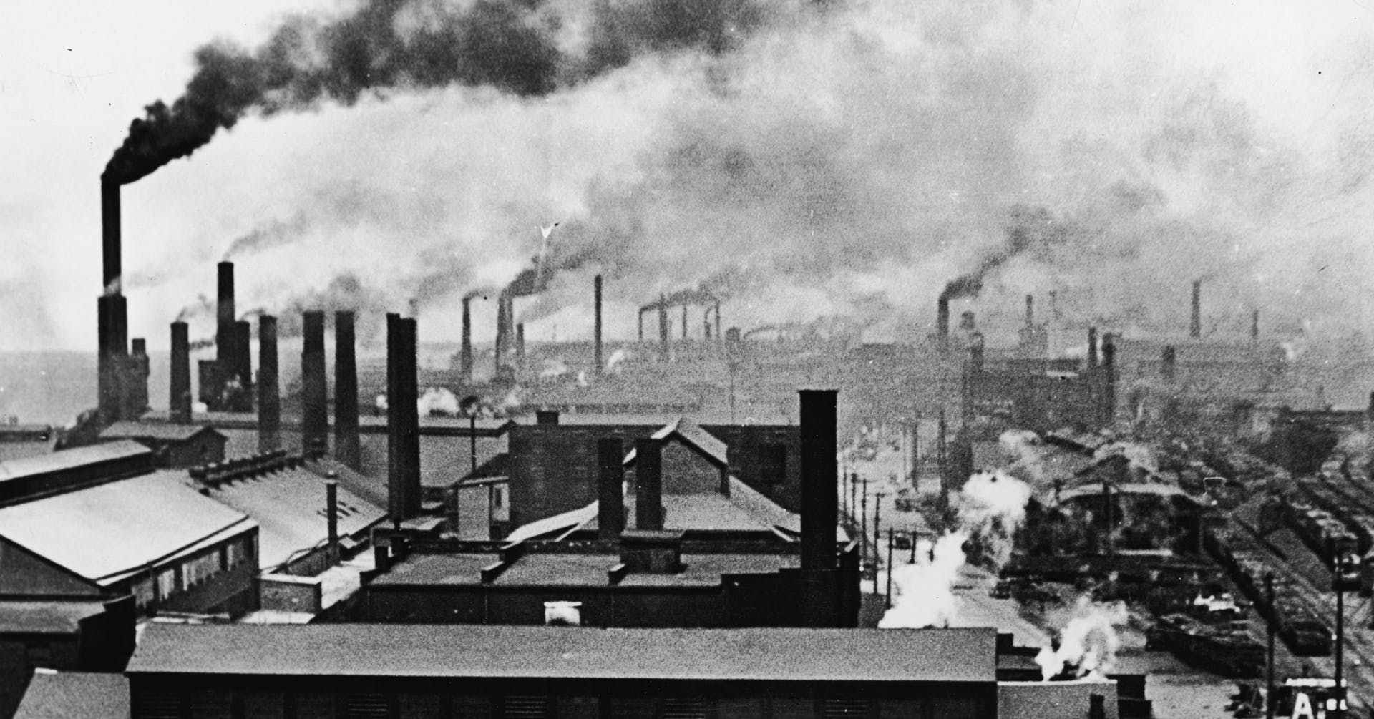
Contents:
- Introduction to A-level History –Britain, c1783-1885 – what topics will be taught over the two years
- Preparing for Unit 1F Industrialisation and the People: Britain, c1783-1885 - activities and tasks that will help your understanding

Section 1: Introduction to History A-level- Unit 1F.

The Transformation of the World
Try to imagine what your life would be like without any machines working for you. Make a list of the machines in your household and on your person; you may arrive at a surprising number.
Now imagine earlier generations during their childhood years. How did they move from place to place? How did they communicate? What foods did they eat?
At one time, humans, fuelled by the animals and plants they ate and the wood they burned, or aided by their domesticated animals, provided most of the energy in use. Windmills and waterwheels captured some extra energy, but there was little in reserve. All life operated within the fairly immediate flow of energy from the Sun to Earth.
Everything changed during the Industrial Revolution, which began around 1750. People found an extra source of energy with an incredible capacity for work. That source was fossil fuels — coal, oil, and natural gas, though coal led the way — formed underground from the remains of plants and animals from much earlier geologic times. When these fuels were burned, they released energy, originally from the Sun that had been stored for hundreds of millions of years.
By Cynthia Stokes Brown

This unit allows students to study change, continuity, cause and consequence in this period through the following key questions:
- How Britain was governed and how did democracy and political organisations change and develop?
- What pressures did governments face and how did they respond to these?
- How and with what results did the economy develop and change?
- How and with what results did society and social policy develop?
- How important were ideas and ideology?
- How important was the role of individuals and groups and how were they affected by developments?

Part one: the impact of industrialisation: Britain, c1783–1832

Pressure for change, c1783–1812
- The British political system in 1783: government and representation; national and local democracy; Whigs and Tories
- Government: Pitt the Younger as Prime Minister and his successors; Pitt's relationship with the King; the 1784 election; reform of finance, administration and trade
- Economic developments: industrialisation; the growth of cotton and other industries; changes in power; the condition of agriculture
- Social developments: the middle class; the industrial workforce; landowners; agricultural labourers and the poor; working conditions; standards of living; the Combination Acts
- Pressures on government: the political influence of the French Revolution; Irish rebellion and union; radicalism and opposition; party splits; demands for parliamentary reform
- Pressures on government: the political, economic and social impact of war; the condition of Britain by 1812

Government and a changing society, 1812–1832
- Government: Lord Liverpool; the Corn Laws and other legislation; attitudes to reform and repression; the economy; the repeal of the Combination Acts
- Government: Canning, Goderich and Wellington; legislation including the repeal of the Test and Corporation Acts; the metropolitan police force; O’Connell and Catholic Emancipation
- Economic developments: continuing industrialisation and developments in key industries; agricultural change; economic policies and free trade
- Social developments: the effects of industrialisation; standards of living and working class discontent
- Pressures for change: Luddism and radical agitation; the anti-slavery movement; Methodism; early socialism and the ideas of Robert Owen
- Greater democracy: the election of the Whigs; pressure for parliamentary reform; the Great Reform Act and its impact; the state of Britain politically, economically and socially by 1832

Part two: the Age of Reform: Britain, 1832–1885

Political change and social reform, 1832-1846
- Government: Grey, Melbourne and the ideas and ideology of the Whig Party; the Tories in opposition and government; Peel and the transformation of the Conservative party
- The Whig response to social change; social reforms including: education, factory legislation, abolition of slavery, the Poor Law Amendment Act, the Municipal Corporations Act
- Pressure for change: Chartism; Irish radicalism; the Anti-Poor Law League; the Anti-Corn Law League; social reform campaigners including Shaftesbury and Chadwick
- The Conservative response to change: finance, administration and the economy; the Bank Charter Act; trade and business reform
- Economic developments: the railway 'revolution' and associated economic growth; agriculture and Corn Law repeal
- Social developments: conditions in urban Britain; changes in the lives of workers and the poor; unions and other working-class movements

Economy, society and politics, 1846–1885

Government and developing political organisation: the development of the political system and party realignment; the emergence of the Liberal Party
- Government and democracy: Gladstone, his ministries and ideas and policies; Disraeli, his ministries, ideas and policies; increasing democracy; legislation
- Pressure for change: social campaigns, Public Health reform; Chartism; pressure for parliamentary reform; Irish Nationalism
- Economic developments: the mid-Victorian boom; the 'golden age' of agriculture; industrial and transport developments; impact of increased trade; the Great Depression
- Social developments: prosperity and poverty in towns and countryside; regional divisions; influences including Evangelicalism; 'self-help'; trade unions and education
- The political, economic and social condition of Britain by 1885; the extent of democracy and Britain’s industrial position

Section 2 – ACTIVITIES TO ENHANCE YOUR UNDERSTANDING

  - Reading

Core Text, recommended to buy:
- Oxford A level History for AQA: Industrialisation and the People: Britain c1783-1885Authors: Ailsa Fortune
Publisher: Oxford University Press (including Nelson Thornes)
ISBN-13: 978-0-1983-5453-6
Publication date: September 2015
Recommended wider reading:
- E Evans, The Forging of the Modern State: Early industrial Britain,1783–1870, Routledge, 2001
- A Briggs, The Age of Improvement: Britain, 1783–1867, Routledge, 1999

Useful websites

- http://www.british-history.ac.uk/
- http://www.nationalarchives.gov.uk/records/looking-for-subject/19th-century-political-history.htm
- http://www.thecore.nus.edu.sg/landow/victorian/victorian.html
- www.indiana.edu/victoria
- www.victorianweb.org
- Historical Association podcasts: http://www.history.org.uk/resources/student_resources_110.html

B. Tasks to help with contextual understanding
Task 1
Create a timeline of political history 1783-1885. Use the following website to help you. Look under the ‘Political History’ section: www.victorianweb.org

Task 2
Write definitions for the following:
- Social/ cultural change
- Economic Change
- Political change
- Environmental change
For each one give examples of how Britain changed during the Industrial Revolution from 1880 onwards. Use this website to help you: https://www.mtholyoke.edu/courses/rschwart/hist151/lectures/lecture10.htm
Summarise the following using your own research: How did the industrial Revolution change Britain?
Task 3
Write a brief history and explanation of the Tory’s and the Whigs
Task 4
Key people:
For each of the following prime ministers note the dates they were in office, the party they served, major acts they passes and any other interesting facts. The following websites will be useful:
https://www.gov.uk/government/history/past-prime-ministers
http://www.bbc.co.uk/history/historic_figures/pitt_the_younger.shtml

- Pitt the Younger
- George Canning
- Frederick Robinson Viscount Goderich
- The Duke of Wellington
- Robert Banks Jenkinson, Earl of Liverpool
- Arthur Wellesley,The Duke of Wellington
Other key people
You do not need to provide short biography just key facts about each person and why they are significant. What impact did they have on history?
- King George III
- Charles Fox
- Daniel O’Connell
- Sir Robert Peel
- Robert Owen
- Ned Ludd

Task 5
Watch and make notes on the following biography on Pitt the Younger: https://www.youtube.com/watch?v=O0tHmYEaqok

C. Films or novels to develop your understanding further
Films or mini-series to help set the scene:
Sharp (ITV) mini-series
Hornblower (ITV) mini-series
North and South (BBC) 3 part mini-series
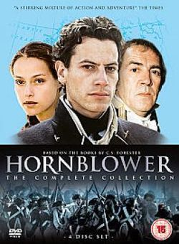
Oliver Twist - why not sing along!
Peterloo (Amazon prime) 2019 film

Read a novel:
These books are set in Britain during these turbulent times these help with empathy for those living and working in these times:
