Business Studies

Home Learning Pack
Challenges

Please find attached a pack of work to help prepare you for Sixth Form and colleges – no matter if you want to study business or not. This will help show Schools/Colleges what you have done during the lockdown – Great evidence of independent Study.
This will go alongside working on exam questions and theory.

If you want to study Business look at the syllabus:
- A Level Business Studies Specification https://qualifications.pearson.com/content/dam/pdf/A%20Level/Business%20Studies/2015/specification-and-sample-assessment-materials/9781446914694_GCE2015_A_BUS_WEB.PDF

Useful websites/apps- register now:
- Register with http://www.tutor2u.net, a Business Studies blog especially written for students. A daily blog will be sent to you with interesting news articles that tie into the syllabus, comments from examiners and (later) tips and support for exam modules

- For (business) news stories use the BBC website http://news.bbc.co.uk

Please email me if you have any queries or questions.

In the meantime, I want to say a big thank you for your hard work at Charles Darwin School and I am so very sorry you have lost your opportunity to complete the exams. During these unprecedented times it’s important to keep going and know we will be back to normal soon.

Kind regards

Mr Manchester
Head of Business and Finance

CONTENTS Page number

- Home Learning Activities Challenges
  - A week in business 3
  - Brands 3
  - Entrepreneurs 4
  - Research 5

- Reading
  - Text Books 6
  - Newspapers and magazines 7
  - Business Reading Books 7-9
  - Websites 9-10

- Films 10-11

- TV Programmes 12-13

- Challenges 13

- Financial Formulas 16-14

- Home Activities

1.1 “A week in Business”.
1 | Select 7 pictures, one for each day to represent a business news story. ( see if there is something different happening not just Coronavirus)
2 | For each story, write a commentary/explanation:  - What is happening  - What has it got to do with business  - Why is it important?
3 | Select the story that you found most interesting. Why was this?
4 | Create a poster showing your pictures

1.2 Choose a Company/brand and research it!
Find out the following – Ownership type, Revenue, Profit, Number of employees, size and scale, name of leader (CEO)

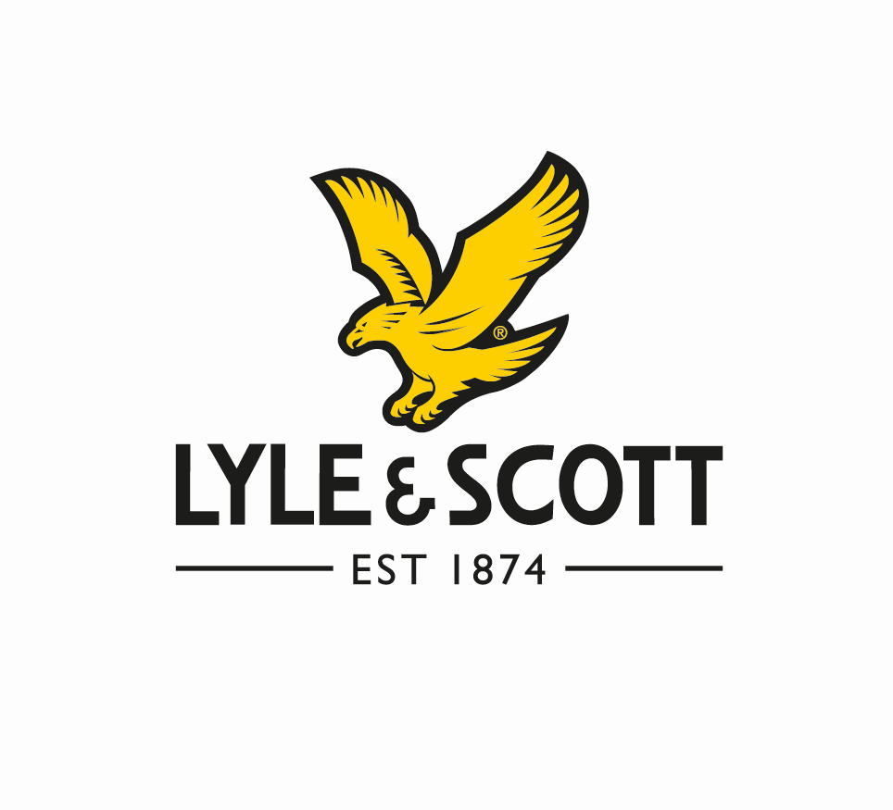

  - Entrepreneurs and Leaders
Research these business people

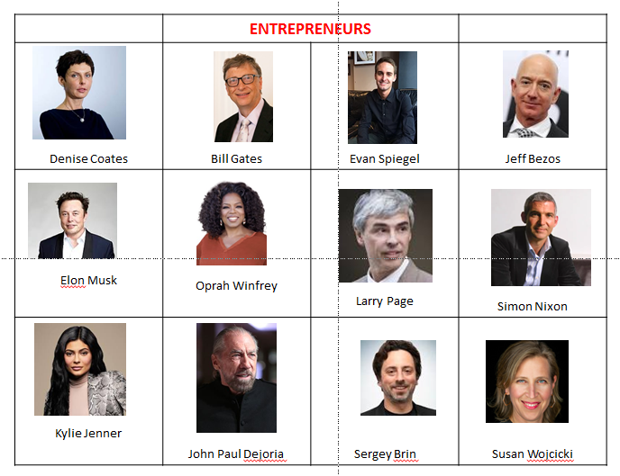
Research these different entrepreneurs and find out the following: -
- What have they done?
- Why are they an entrepreneur?
- How did they do it?
- What is their net worth?

1.4 Research Activity

Present your information as a report, PowerPoint presentation or poster.

- Select a company
(picking a Public Limited Company (PLC) will make it easier to find information on the internet).

- Research some basic facts:

- Research the term “Annual Accounts for your chosen .PLC”
- Download the PDF
- Read the chairman’s and CEO message at front of the pack
- Look through the pack to find the financial information (Income statement) this will show the revenue and profit.

Explain the following
- What does the business do?
- How large is it?
- Where is it based?
- What are its key objectives? (Hint: look in the Chairman’s statement in the annual report)

- How successful is it?
Give evidence (Think about numbers: sales revenue, profit, market share etc. and get facts and figures).

- Has it become more or less successful over the last few years?
(again, get evidence from annual report, compare finance for a few years)

- What do you think are the key factors that affect its success and why? (Think about competitors, Government regulation, the economy, its financial situation etc.)

- Evaluate what impact the coronavirus has on this business?

- READING

2.1 Business Text Books
Once the term starts, we recommend that you have purchased your own copy of the recommended textbook or e-book for your chosen course. Other book, revision guides are available, but make sure that they are EDEXCEL approved and cover the specification for first teaching in 2015. I have put the Amazon prices here but they may be available at other outlets

Main Text Book – I have electronic copies if you would prefer  (YEAR 12)  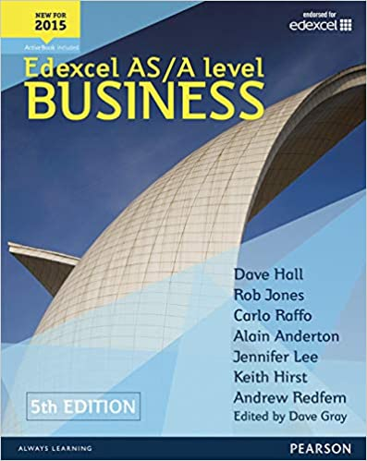  ISBN-978-1447983545  £34.94 | Revision Guide  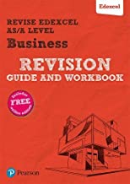  ISBN 978-1292213217  £10.77 | Revision Guide  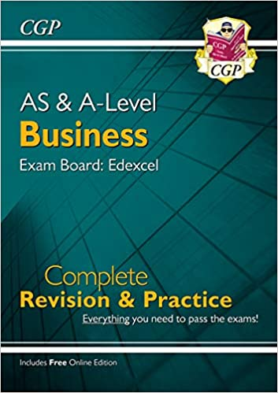  ISBN 978-1789082425  £17.99
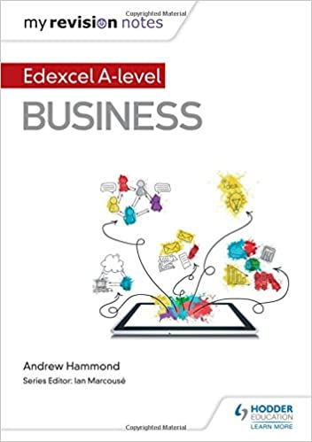  ISBN 978-1471883224  £14.72 | Revision Workbook  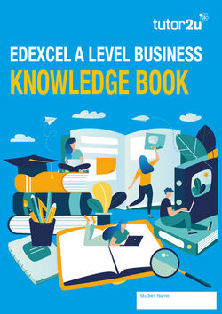  Available from your teacher | Calculation workbook  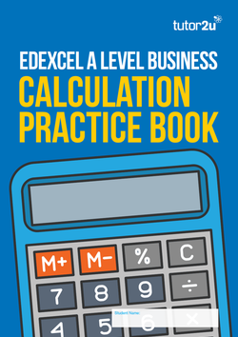  Available from your teacher

Other recommended reads - Quality newspapers/magazines such as The Times, Guardian, Telegraph, Independent, journals such as The Economist (N.B there are reduced rates for students on some of these, for example, students were able to buy The Economist for 6p per copy instead of the standard £2!) Also, you can sign up online and receive free articles.

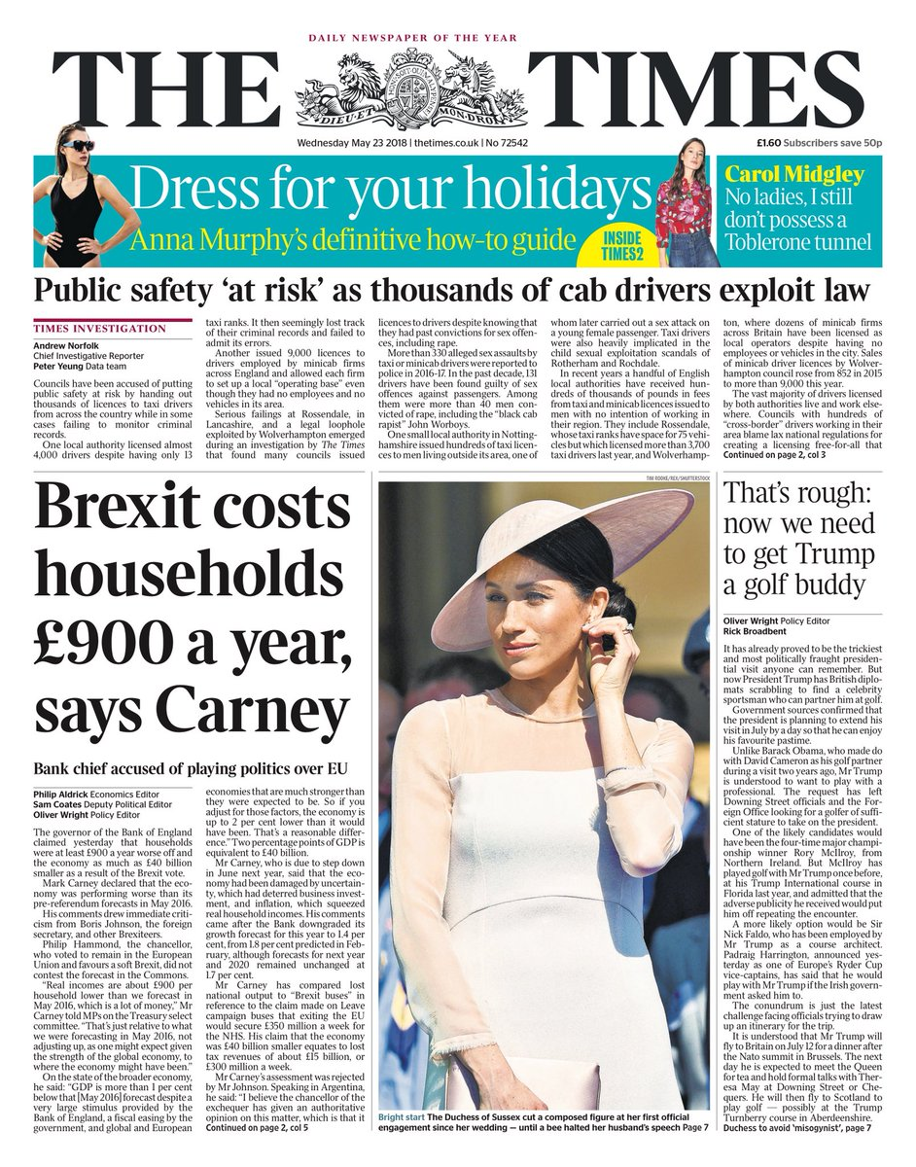  www.thetimes.co.uk | www.independent.co.uk | www.economist.com | 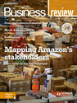  https://www.hoddereducation.co.uk/ magazines/ magazines-extras/business-review-extras

2.2 Business Books

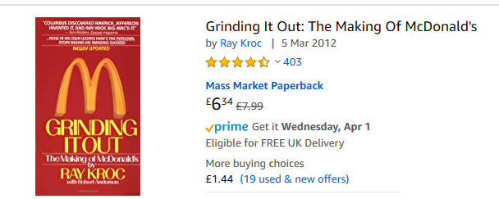
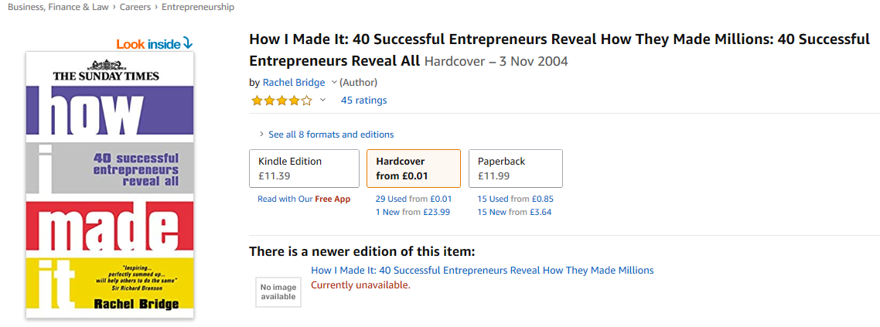
An essential read for anyone that is thinking about starting their own business. Successful Entrepreneurs are interviewed about how the spotted a gap in a market, and developed a USP.
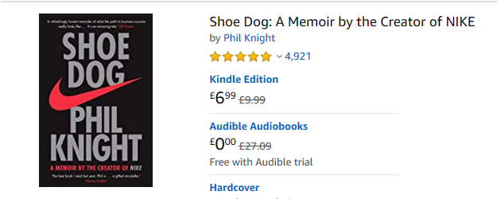
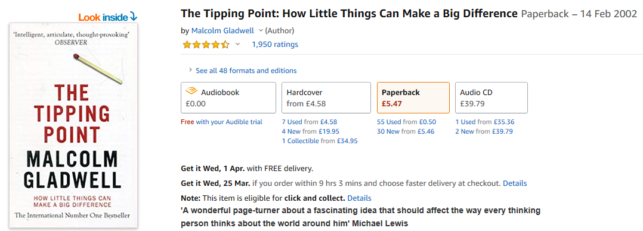
A very readable and fascinating book, which looks into the reason’s products become market leaders.
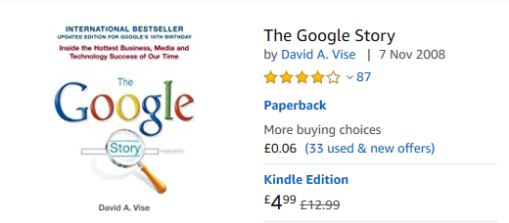
An interesting investigation into the culture at Google, includes insights into the four-day working week and soft management styles. The questions are; are these the things that made Google the world’s number one search engine?
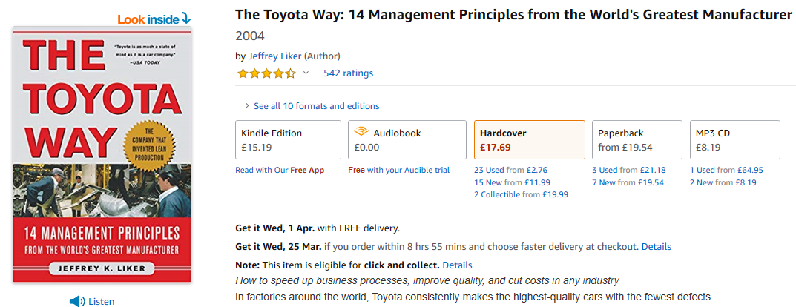
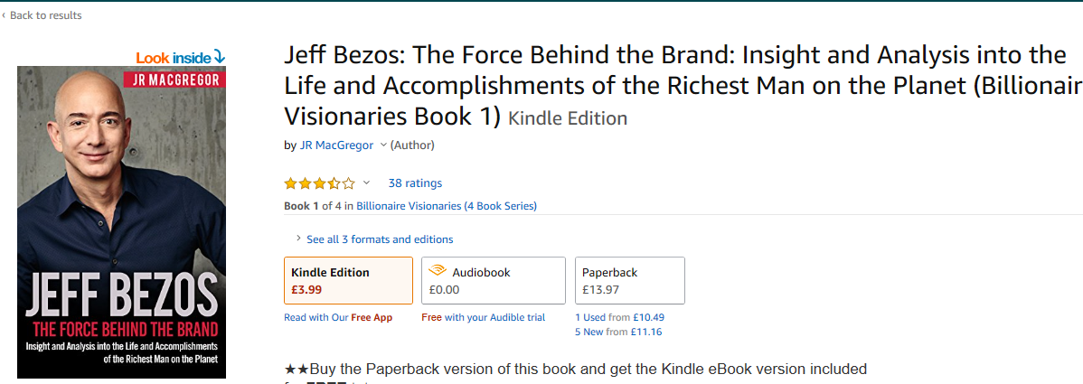
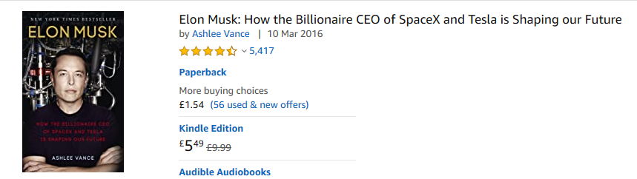
Recommended websites/follow on Twitter/ Apps on your mobile.

www.tutor2u.net  Excellent business website with everything you need to learn for Business A Level, presentations, videos, revision quizzes. | www.bbc.co.uk  Excellent news website with everything you need to learn about what is going on in the world today | www.londonstockexchange.com  Excellent website with everything you need to learn about share prices and market capitalization.
https://beta.companieshouse.gov.uk/  Excellent website which allows you to research any registered Private Limited Company LTD in the UK. | https://ig.ft.com/sites/numbers/economies/uk/  Excellent website for researching the UK economy at a glance. The FT’s one-stop overview of key economic data, including GDP, inflation, unemployment, the major business surveys, the public finances and house prices | Really useful YouTube channel with wide range of revision videos on all business a level topics
People to follow on Twitter/instagram/ Facebook#

Richard Branson
Jeff Bezos
Lord Sugar
Virgin
Peter Jones

3.FILMS
Watch something about business on Netflix*

- Up In The Air with George Clooney (2010);
Up in the Air is a 2009 American comedy-drama film directed by Jason Reitman and written by Reitman and Sheldon Turner, based on the career of J Weller. The story is centered on corporate "downsizer" Ryan Bingham (George Clooney) and his travels.

Business reference: Human Resources, retrenchment
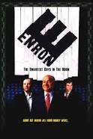 | - Enron: The Smartest Guys in the Room (2005);  The film examines the 2001 collapse of the Enron Corporation which resulted in criminal trials for several of the company's top executives during the ensuing Enron scandal it also shows the involvement of the Enron traders in the California electricity crisis.  Business reference: Profit, Public Limited Companies, Stock market, insider trading
Glengarry Glen Ross” (1992)
This film follows the lives of four unethical Chicago real estate agents who are prepared to go to any lengths (legal or illegal) to unload undesirable real estate on unwilling prospective buyers.

Business reference: Profit
- Working Girl (1988)
This film showed the world that a woman could be just as successful and smart as any man in business. Today that seems like a given, but in 1988 it seems like it was still pretty revolutionary.

Business reference: Human Resources, Motivation, Entrepreneur

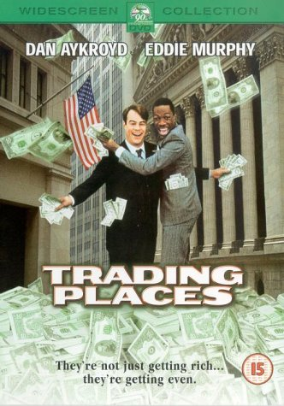 | - Trading Places (1983);  Trading Places is a 1983 American comedy film directed by John Landis and starring Dan Aykroyd and Eddie Murphy. It tells the story of an upper-class commodities broker and a homeless street hustler whose lives cross paths when they are unknowingly made part of an elaborate bet.  Business reference: profit, stock market
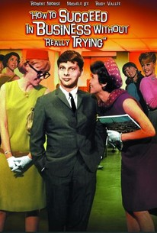 | - How to Succeed in Business Without Really Trying (1967).  Pierpont Finch (Robert Morse) is a lowly window cleaner with dreams of making it big in the business world. After finding a copy of the book "How to Succeed in Business Without Really Trying," Finch decides to apply the tactics in the book to his own life.  Business reference: entrepreneurial characteristics profit,
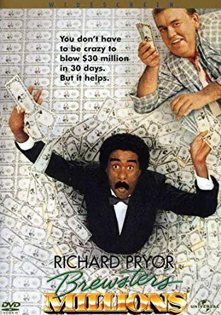 | - Brewsters Millions  After losing his position as a minor-league pitcher, Montgomery Brewster (Richard Pryor) learns his great-uncle has left him $300 million. To inherit it, Brewster must spend $30 million in 30 days under a complicated set of rules that forbid him from donating too much to charity or retaining any new assets when the period is up. Unable to share details about the will's odd conditions with anyone,  Business reference: money, assets
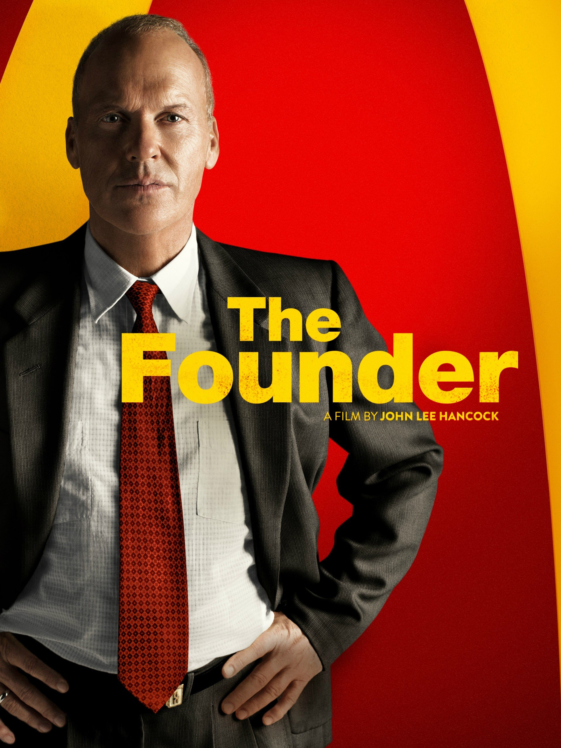 | - The Founder  The true story of how Ray Kroc (Michael Keaton), a struggling salesman from Illinois, met Mac (John Carroll Lynch) and Dick McDonald (Nick Offerman), who were running a burger operation in 1950s Southern California. Kroc was impressed by the brothers' speedy system of making the food and saw franchise potential. Kroc soon maneuvers himself into a position to be able to pull the company from the brothers and create a multi-billion dollar empire.  Business reference : Franchising
- Pursuit of Happyness
The Pursuit of Happyness is a 2006 American biographical drama film based on entrepreneur Chris Gardner's nearly one-year struggle being homeless. Directed by Gabriele Muccino, the film features Will Smith as Gardner, a homeless salesman.

Business reference : Entrepreneurial spirit, sales, finance

*Some of these films may include mature themes so please check the ratings before watching.

4. TV

The following television programmes are recommended for background business knowledge. Make notes on any of the relevant business information you found out about. Day and date it.

BBC News  Last news from around the world. | BBC Panorama  British current affairs documentary programme | BBC newnight  Key national and international news stories
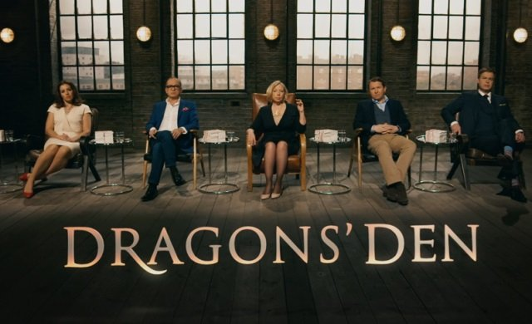  Dragons Den  Programme about entrepreneurs presenting their business ideas to gain funding from the Dragons. (Venture Capitalists) | The Apprentice  Programme about entrepreneurs working in teams and being interviewed so they can gain backing of Sir Alan Sugar for their business idea. | 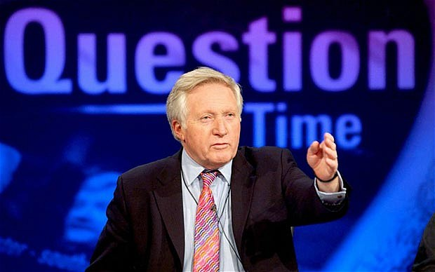  Question Time  Topical debate in which guests from the worlds of politics and the media answer questions posed by members of the public.
Undercover Boss  A CEO goes undercover to find out how a large firm is running. There are both UK and USA versions. Check catchup TV or YouTube | Inside the Factory  A fun insight into foods we eat and how they are made. Shows student the different production methods used. | Only Fools and Horses  Bit of comedy. The original sole trader “Del Boy”. Show goes through the trials and tribulations of Trotters Independent Traders!

- CHALLENGES

Choose any of the challenges from below – 1 a week.

Register with the Duke of York Inspiring digital enterprise award.  This is a great way to attain an additional qualification online | Collect 3 interesting news article from the BBC website. Put them on a sheet and annotate around the related to theory we have covered in business lessons | Create a fact sheet on how 4 different businesses have been affected by and responded to the Covid -19 outbreak. Businesses face risks all the time and need to adapt to them.
Read an autobiography of an entrepreneur that interests you. Take notes on the interesting facts | Collect some chocolate bar wrappers and create poster to explain how each target different segments. Relate any other theory you can to the products | Watch an episode of Inside the Factory (available on the Smithsonian Channel) and summarise the production and quality methods they use. Apply/mindmap any theory that you can relate to the programme.
Watch any of the Inside series on Channel 4 on demand( e.g Inside Rolls Royce, Inside Aldi etc) | Watch Channel 4 series ‘The Job Interview’ available on Chanel 4 on demand. What went well, what would you recommend both the business and interviewee could do better. | Research the stock market, how it works, track how prices changes and present this information in a poster
Watch an episode of Dragon’s Den and critically evaluate each pitch. What went well? What could have gone better? Would they invest? If so, how much? If not, why not? | Watch an episode of Ramseys Kitchen Nightmares (Channel 4, On demand, You tube) and bring in all the theories that you can relate to the episode. Create a mind map | Create your own business – start thinking about what type of business you would like to run and develop a business plan for the idea ( further information will be uploaded onto the classroom regarding this tasks )
Watch any of the following on Channel 5 – Burger Wars, Supermarket Wars, Inside - Aldi, Inside Iceland, Harrods,DHL etc and make notes on the business and any theory that you can relate to the programme.

- FINANCIAL FORMULAS YOU WILL LEARN! (NOT NECESSARY IF NOT TAKING A LEVEL BUSINESS)

EDEXCEL – KEY FORMULAS
You could create your own revision cards to get started!

No | FORMULA
1 | BUSINESS BASICS  - Revenue (Sales or Turnover) = Selling price per unit × Quantity of units sold  - Variable costs (Total variable costs) = Variable cost per unit × Number of units sold  - Total costs = Fixed costs + Variable costs  - Profit = Total revenue −Total costs OR Total contribution −Fixed costs
2 | Market growth (%) =  Change in the size of the market over a period  Original size of the market × 100  REMEMBER New – Old x 100  Old
3 | Market share (%) =  Sales of one product OR brand OR business X 100  Total sales in the market
4 | Added value =  Sales revenue − costs of bought-in goods and services
5 | Labour productivity =  Output over a time period  Number of employees
6 | Unit costs (average costs)=  Total costs  Number of units of output
7 | Capacity utilisation (%) =  Actual output  Maximum possible output × 100
8 | Return on investment (%) =  Profit from the investment (£)  Cost of the investment (£) × 100
9 | Gross Profit = Revenue* − Cost of Sales  Profit from Operations = Operating profit = Gross profit − Operating Expenses  Profit for year = Operating profit + Profit from other activities − Net finance costs −Tax  * Can be called other things e.g. Turnover, Sales, Income all means the same thing
10 | Gross profit margin (%) =  Gross profit  Revenue × 100  Profit from operations margin =  Operating profit margin (%) =  Operating profit  Revenue × 100  Profit for year margin (%) =  Profit for year  Revenue × 100
11 | Variance = Budgeted figure – actual figure
12 | Contribution per unit = Selling price − Variable costs per unit  Total contribution = Contribution per unit × Units sold  OR Total contribution = Total revenue − Total variable costs
13 | 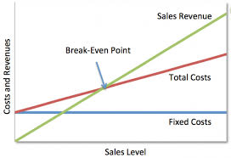  Break-even output =  Fixed Costs  (Selling Price – Variable Cost per unit)*  *(Also known as Contribution per unit)  Margin of safety = Actual level of output − Break-even level of output
14 | Labour turnover (%) =  Number of staff leaving  Number of staff employed by the business × 100
15 | Employee retention rate (%) for a particular time period =  Number of employees who remained with the business for the whole period of time  Number of employees at start of the time period ×100
16 | Employee costs as percentage of turnover =  Employee costs  Turnover × 100
17 | Labour cost per unit =  Labour costs  Units of output
18 | Return on capital employed (ROCE)(%) =  Operating profit  Total equity + non-current liabilities × 100  Where total equity + non-current liabilities = capital employed
19 | Current ratio =  Current assets :1  Current liabilities
20 | Acid Test ratio =  Current assets - Inventory :1  Current liabilities
21 | Gearing (%) =  Non-current liabilities  Total equity + non-current liabilities ×100  Where total equity + non-current liabilities = capital employed
22 | Average rate of return (%) =  Average annual return (£)  Initial cost of project (£) × 100

