Charles Darwin School
Assessment and Marking Policy

Persons Responsible:
Governors: Curriculum Committee
SLT: Mick Boyden
Written by: Mick Boyden

Formally approved by the Curriculum Committee on: 12 March 2018
Next review date: June 2021

Table of Contents

1. Aims 3
2. Organisation and layout of pupil work 3
3. Effective marking and feedback 4
4. Marking Policy 4
5. Frequency 5
6. General Points 6
7. Standard Symbols to be used for marking 7
8. Key Stage 3 Assessment 8
9. Key Stage 3 Thresholds 8
10. Target Setting and monitoring progress for 2017-18 11

- Aims
  - The aim of the Assessment and Marking Policy for students is
    - to inform them of their progress and motivate them to improve their performance
    - to help them identify the criteria by which they can improve their performance
    - to help them reflect on learning outcomes
    - to help them become effective independent learners.
  - The aim of the Assessment and Marking Policy for teachers is
    - to inform them of the progress that students are making
    - to identify individual learning needs
    - to evaluate the impact of their teaching on students' knowledge, understanding and skills
    - to reinforce expectations of students’ attitude to work.
- Organisation and layout of pupil work
  - At KS3 and KS4
    - All books/files should contain the CDS Threshold grid (KS3) or (KS4) GCSE success criteria.
    - All books/files must have a tracking document illustrating progress over time.
    - All pupil work at KS3 and 4 should have a date, title, learning objective [LO] if appropriate and be labelled with the intention of the work i.e. class notes, homework, deeper learning activity, test, assessment etc.
  - At KS5
    - At KS5 file dividers should break up the folders in following areas and evidence 2 years of progress through the A level course:
    - Bridging unit work – 11 into 12 and 12 into 13
    - Criteria – in here there should be a copy of the following:
- Syllabus
- Marking criteria AO objectives
- PLC or other pupil evaluation checklist
- Past papers
- List of deadlines and important dates
    - Assessments
- Resits and improvements of marked tests
- Marked tests
- Evaluation of marked work

    - Coursework
- Written evidence of marking and advice, evaluation and improvements
- Log of recordings or separate work book/portfolio
    - Classwork and notes – this is a pupil area that will probably be unmarked work.
- Effective marking and feedback
  - Effective marking and feedback
    - provides constructive feedback which helps pupils to understand what they have achieved and sets next steps now targets;
    - encourages pupil interest through questions which are followed up;
    - provides dedicated opportunities in lesson time for students to responds to teacher feedback e.g re writing an identified paragraph , completing a more challenging question, explaining a point in more detail;
    - provides opportunities for pupils to mark their own and others' work;
    - focuses on learning objectives and subject-specific knowledge, understanding and skills;
    - promotes high expectations of the quality and presentation of pupils' work;
    - is focussed and targeted in order to make it meaningful for the pupil and manageable for the teacher and
    - is expressed in clear language appropriate to the needs and abilities of the individual
  - Overall, the frequency, level of detail and the format of marking and feedback will vary from student to student, subject to subject and by Key Stage. However, the judgement on its effectiveness and appropriateness is measured by the overall progress made by students, which should be at least good.
  - It is not expected that student work should be unmarked in any form for longer than 3 weeks.
- Marking Policy
  - The effort grade criteria are the same for every department in the school from Y7-11; 1 is the highest, 5 is the lowest. This fits with criteria used for Annual Reports and CAPP
Excellent effort 1
Good effort 2
Requires Improvement 3
Poor effort 4
Inadequate 5
See Behaviour for Learning Grid for further details
  - NB: it is expected on occasions where 5 is awarded for effort with a piece of work that the student is asked to repeat that piece of work, either at home or in a detention.
  - Attainment at KS3 should be expressed principally in language which relates to the CDS Thresholds that subject areas have developed in relation to the knowledge and skills that they feel students should develop in KS3. These are as follows:
Excellence
Advanced
Secure
Embedding
Developing
See KS3 Assessment Policy CDS Thresholds for detail.
  - Attainment at KS4 should be expressed principally in GCSE numerical grades or their GCSE equivalents or fine grades for example:
5+ meaning a strong grade 5
5= meaning a secure grade 5
5- meaning a weak grade 5
  - NB KS4 in terms of marking begins in the Summer Term of Y9. In the first 2 terms of Y9 subjects will use CDS Thresholds as the curriculum bridges between KS3 and GCSE.-
  - Attainment at KS5 should be expressed principally in A level or A level equivalent grades or fine grades for example B+.B- or Merit +/M-
- Frequency
  - At KS3 it is expected that evidence of three* deeper learning activities and one test should be seen and to have been marked in this way per term.
* This is dependent on number of lessons per week- See KS3 Assessment Policy CDS Thresholds for detail.
  - Where attainment is graded in such a way there should be a “next step now” target included in the comment focusing on the action required by the student on how to improve their work with an opportunity for students to respond to teacher feedback and marking.
  - Time will need to be allocated during lessons for pupils to be able to respond to feedback. Evidence of this might be a re-working of a paragraph, corrections, answering a learning question posed in the feedback etc. This process is referred to as Dedicated Improvement Time. (DIT)
  - The remainder of the work including homework should be marked with the frequency and level of detail so as to ensure that students’ progress overall is at least good. The level required will therefore vary from student to student.
  - At KS4 it is expected that marking, feedback and student reflection takes place with the frequency and level of detail necessary to ensure:
- Students’ progress is at least good
- Students’ knowledge and understanding of what they need to improve, the target they are capable of achieving and the steps they need to take to get there are clear
- Subject staff and leaders are able to monitor student progress towards academic targets with the confidence that the grades being entered for CAPP are an accurate reflection of students’ performance.
  - At KS5 it is expected that marking, feedback and student reflection takes place with the frequency and level of detail necessary to ensure:
- Students’ progress is at least good
- Students’ knowledge and understanding of what they need to improve, the target they are capable of achieving and the steps they need to take to get there are clear
- Subject staff and leaders are able to monitor student progress towards academic targets with the confidence that the grades being entered for CAPP are an accurate reflection of students’ performance
- General Points
  - Literacy is the responsibility of all teachers. Please see below for standard symbols to be used. The frequency and level of corrections required are those that best bring about the improvements in students’ written work for example corrections, highlighted mistakes , repeating unsatisfactory work
  - Opportunities should be planned for marking criteria relating to specific pieces of work to be shared with students.
  - Moderation of work assessed to national criteria should occur within departments and portfolios of exemplar work developed and updated.
  - There are a range of strategies available which can speed up the marking process without reducing its effectiveness, provided they are matched to the intended learning outcomes of the work and feedback. These include:
    - individual or pair marking of content or presentation, prior to the work being handed in to the teacher
    - correcting of particular features in part of the work before asking pupils to self-mark the remainder for the same errors
    - focus marking on a single feature, which has been made clear to the pupils in
    - advance
    - sharing exemplar material with the whole class to model the expected outcomes
    - sharing common issues that arise from a set of marking with the class or groups of pupils rather than writing detailed comments on all work individually, giving time for students to note down key points.
  - Some consideration is required in terms of marking work when students are identified as Potential High Achievers (PHA). Please consider the criteria carefully before awarding grades for effort to ensure these learners have extended themselves sufficiently when opportunities arise.
  - Some consideration is required in terms of marking work when students are identified as SEND. Clearly this will be dependent on the individual needs of student, but in general the following provides some general guidance:

    - Do not ‘over-correct’ spelling errors – focus on key subject vocabulary & common words where misspelling affects meaning
    - Ensure handwriting of any feedback comments is clear (as students find handwriting harder to read than type-face).
    - Consider the complexity of sentence structure and vocabulary in feedback comments – ensure it is appropriate for the student’s ability.
    - Peer marking should be used very carefully – consider any impact on self-esteem; often the instant-feedback of self-marking is more beneficial
    - Consider praising the effort represented by the work as well as the content.
- Standard Symbols to be used for marking
  - The following standard symbols are to be used for marking for clarity:
sp spelling error- underline the word or part of word and write “sp” in margin/ add in correction
0 punctuation error- underline the error/add in correction
??~~ error in expression – underline relevant part of written work
ll new paragraph
^ a word/part of sentence is missing

- Key Stage 3 Assessment
  - Context
In addition to changes at GCSE and A level the government has in recent years also radically changed the curriculum in KS3 for our students in Y7 and Y8. As a result of this the old systems of levels is no longer applicable. In response to these changes the Assessment without Levels (AWL) Working Group agreed the following features for a replacement to the old NC levels. At CDS we wanted to develop a system that
    - is based on developing the key knowledge and skills required for success at GCSE
    - Is based on our high expected standards of students
    - Incorporates formative feedback which encourages and guides all students to succeed – and so develops a growth mind set
    - Incorporates periodic summative assessment to support this ongoing formative feedback
    - Is simple and easy to understand – for staff, parents and students.
    - Has consistent principles, to be used across subjects, but the flexibility to be suitable for all subjects
- Key Stage 3 Thresholds
  - Each subject area has developed a set of Thresholds for Y7, Y8 and for the first 2 terms of Y9. These Thresholds reflect what students need to master, in terms of knowledge and skills, by the end of Key Stage 3, in order to be successful at GCSE. These are linked with the NC Programmes of Study.
  - The standards and requirements for each Threshold are linked with progression towards GCSE grading which is also changing to a numbered system of 9-1. The standards and requirements are more demanding as students progress through Y7-9. The Thresholds in Y10 and Y11 are to show how the Thresholds in Y7-9 link to GCSE grades and are for the purpose of indicating an expected “ flight path” or projection of progress for a student in Key Stage 3 .
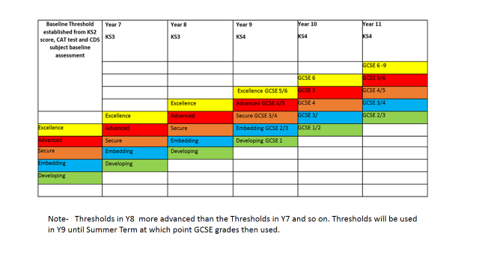
  - In this way the link is made between each Threshold and expected standards at GCSE. The Thresholds in Y7 and Y8 were designed in part by considering the following: If student is capable of achieving for example a grade 8/9 at GCSE, what type of knowledge and skills do they need to have “mastered” in each term of Y7 and then throughout Y8 etc.in order to be progressing as expected?
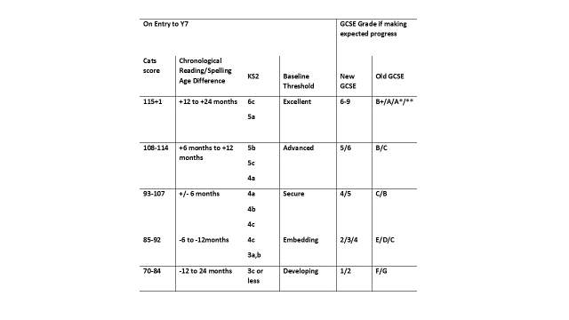
  - As the diagram above shows students will be placed into a Baseline Threshold based on a range of information when they join CDS. Their progress is then assessed against this Threshold. The Baseline Thresholds are linked to GCSE grading is set out below.
  - N.B GCSE targets will be reset for students when they begin their GCSE subjects in Y9 based on FFT estimates.
  - In each subject area students will have copies of the Thresholds in their exercise books. These can be referred to as part of normal teaching, assessment, marking and feedback. Students will not be given a specific target to work towards in the same way as with the previous NC Levels e.g. 6c, 5a and so on. Formative comments on assessed pieces of work should focus on the skills and knowledge required to reach the next Threshold or consolidate some aspects of the Threshold that a student is currently working at.
  - Teacher feedback will reflect whether students are making sufficient progress according to their expected “flight path”. This will be reported formally to parents on 3 occasions in the academic year. The CAPP (Common Assessment of Progress and Performance) will show the following:

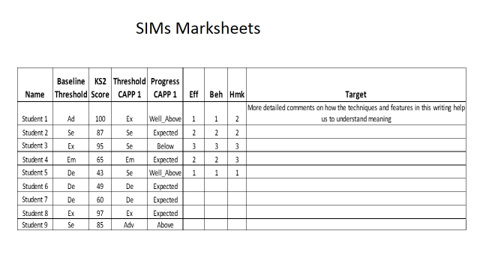

  - On the example below note how the teacher in each case has commented on progress at CAPP 1 in relation to the Baseline Threshold. This should also be reflected in the effort grades.
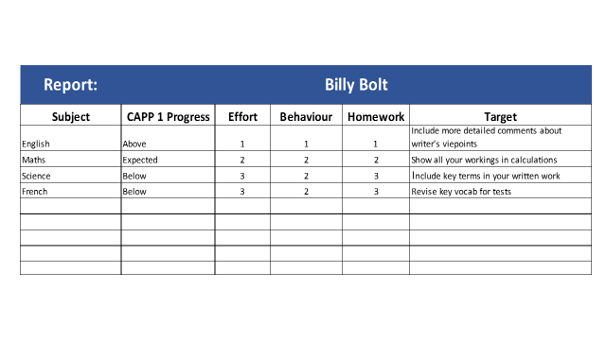
  - Example of awarding Progress grade.
Student | Baseline and potential “flight path” | Threshold achieved via Deep Learning Activity/Test | Progress grade that should be entered ON CAPP sheet*
Adam Apple | Advanced | Advanced | Expected
Olivia Orange | Secure | Advanced | Above
Bobby Banana | Embedding | Advanced | Well above
Katie Kiwi | Excellence | Advanced | Below

*Some degree of staff discretion allowed here.
  - Whilst students will not have specific targets to work towards, subject staff are aware of students’ potential based on the Baseline Threshold and should ensure that in their lesson planning, marking and feedback they are setting work that is challenging for all students using the Baseline Threshold information. We have avoided giving students individual targets such as “you should be aiming for Secure” as we do not believe that this fits well with our broad approach to student motivation via the concept of growth mindset.
  - In each subject area students should be aware of what is required to “master” each Threshold and they should be aiming to progress as far up the Thresholds as possible. This is based on hard work in class and at home, learning from their mistakes and being guided by quality feedback from teaching staff.
  - Subject staff will decide the frequency with which Threshold Descriptors are used on individual pieces of work in line with school policy. The following is a guide to the minimum expectation at KS3:
Curriculum Time | Minimum number of Threshold Assessments per term
1 lesson per week | 1 Deep Learning Activity and formal 1 test
2 lessons per week | 2 Deep Learning Activities and formal 1 test
3 or more lessons per week | 3 Deep Learning Activities and 1 formal test

- Target Setting and monitoring progress for 2017-18
  - Key Stage 5
    - Continue with ALPS. Individual student targets are based on the 75th percentile. This would mean if achieved progress would be in the top 25% nationally.
    - Progress measured against 2 year targets
    - Use internal ALPS spreadsheets for individual subjects and for students by ability band, gender, and disadvantaged
    - Use 4Matrix KS5 to monitor subjects in the same way as used at KS4. Can also measure the progress of KS5 cohort against Performance Measures via Press Release

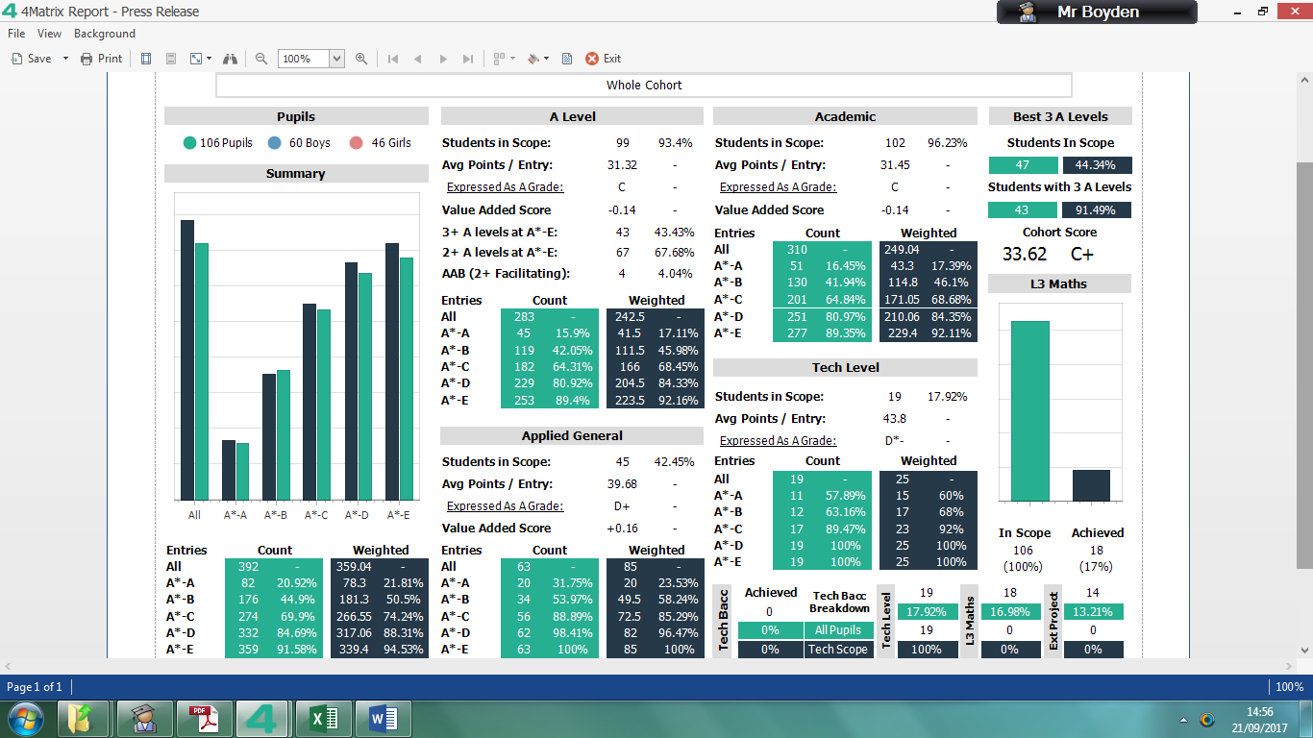
  - Key Stage 4
    - Individual targets arrived at from FFT20 estimates. These are refreshed in September. Some are adjusted to ensure that student P8 is positive.
    - Subjects will have global targets for 9-7, 9-5, 9-4 and APS. These will be calculated more accurately than the targets in the series comparison section of 4Matrix as it takes into account the chance that individual students have of meeting their target. The global targets for a subject will be set out as a range from Average, High and Very High.
    - Subjects will be tracked against their global targets on Excel Spreadsheet from MBO for Y11.
    - Achievement in KS4 will be tracked via 4Matrix as in previous years. Research groups are being refined.
    - Sarah Harvey also produces internal CAPP sheets showing effort and progress for reach subject, cohort and by pupil group
  - Key Stage 3
    - We do not have targets in KS3 we have a potential flight path against which students’ progress is measured- using CDS Thresholds- see handbook
    - This is monitored by subject from Progress Grids produced by JSi and internal CAPP sheets showing effort and progress for each subject, cohort and by pupil group produced by Sarah Harvey

 | Excellent - 1 | Good - 2 | Requires Improvement - 3 | Poor - 4 | Serious concern - 5
Classwork effort and attitude | - Completes work in full and to the best of ability at all times  - Presents work extremely well and takes a great deal of pride in work  - Seeks challenge and perseveres- will almost always attempt more challenging aspects of work  - Asks questions to extend thinking  - Approaches learning with an active interest  - Responds positively to feedback  - Eager to learn from setbacks and mistakes | - Completes work in full and to the best of ability the majority of the time  - Presents work well and takes pride in work  - Seeks challenge and perseveres - will often attempt more challenging aspects of work  - Asks questions to extend thinking sometimes  - Approaches learning with an active interest most of the time  - Normally responds positively to feedback  - Is able to learn from setbacks and mistakes | - Only completes work in full some of the time and often not to the best of ability.  - Presents work well on occasions but too often does not take enough pride in work  - Only really completes work to a minimum standard overall  - On occasions asks questions to extend thinking  - Approaches learning with some interest  - Is able to learn from setbacks and mistakes but this is too infrequent to improve overall quality of work | - Poor effort with work with tasks rarely completed anything but a minimum standard  - Little evidence of work being presented with pride and care  - Little enthusiasm shown in approach to learning | - All aspects of effort and attitude to work are of a serious concern
Behaviour and conduct | - Seeks solutions to difficulties  - Sets an example  - Takes responsibility for own behaviour  - Shows respect and understanding to others | - Follows instructions first time of asking  - Shows kindness, consideration and respect  - Listens carefully  - Behaviour supports not distracts others | - May distract others  - Can be off task  - Requires reminders to follow instructions | - Requires direct supervision to ensure tasks are completed  - Reluctant to understand the views of others  - Rarely takes responsibility for their own behaviour | - Often distracts others and prevents learning of others  - Does not follow instructions  - Disrupts the classroom or school environment  - Does not take responsibility for own behaviour
Homework | - Extremely well organised  - Always meets deadlines  - Completes work in full and to the best of ability at all times  - Presents work extremely well and takes a great deal of pride in work  - Seeks challenge and perseveres - will almost always attempt more challenging aspects of work | - Well organised  - Normally meets deadlines  - Completes work in full and to the best of ability on most occasions  - Presents work well and takes pride in work  - Seeks challenge and perseveres - will often attempt more challenging aspects of work | - Let down by organisation sometimes  - Only completes work in full some of the time and often not to the best of ability  - Presents work well on occasions but too often does not take enough pride in work  - Only really completes work to a minimum standard overall | - Work is poorly organised  - Often fails to meet deadlines  - Little evidence of work being presented with pride and care  - Poor effort with work, tasks rarely completed to anything but a minimum standard | - All aspects of homework in terms of both effort and quality are of serious concern

