Information for Students and Families for working from home.
With the concerns around the Coronavirus COVID19 and the need for students to be working from home, either through self-isolation or family isolation, or with the need to close the school for some or all year groups, we have put together some guidelines to support students and their families working from home over an extended period of time.
Families will be concerned over what work to cover, how long to cover and how work will be assessed. Learning for all year groups will be placed centrally on Show My Homework (SMHW). All parents and students should have the App or login details. For families who have changed mobile device or lost login details, anyone can access SMHW through our website here.
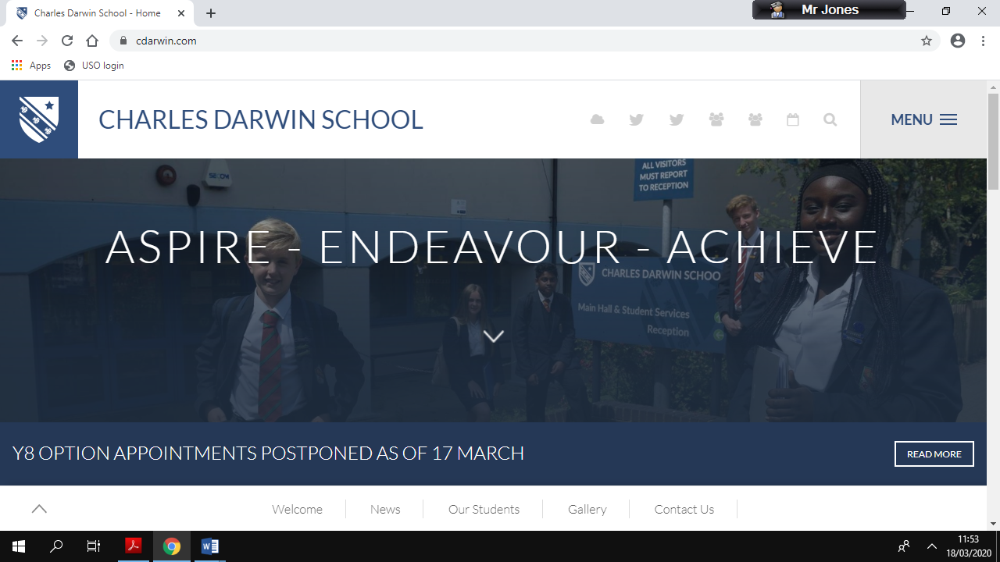

How often is work set on SMHW?
Teaching staff will be regularly be updating work on SMHW. A good idea would be to log on each day to check for updates. For some year groups and subjects, longer term project work may be set and guidance on the length of time that this will take will be instructed on SMHW. Please do bear in mind the responsibilities of teaching staff to their own families and how this may impact on the volume of work posted. For further guidance on work beyond SMHW, please read the final paragraph.

How long students should be working
Students should not be working for long blocks of time without a break. Keep learning to short focused sessions and then take 20-30 minutes break in between learning episodes. Make sure the break is away from the working area and allow time for relaxation. Much of the workload of the brain takes place in between learning episodes, which allows the brain time to process and order new information.

What should students be working on?
Some students may have their exercise books or folders and it is perfectly fine for work to be completed in books. Please make sure of the same high standards of presentation in books. Some staff may ask for students to produce work electronically on Word or Powerpoint. Where families do not have access to the Microsoft Office documents, sites such as Google Docs produce their own free versions which can be saved as Word/Powerpoint documents. Some students, in particular GCSE and A Level will have access to exam questions through websites and should take instruction from teaching staff. Printing off large volumes of paper can be expensive for families so you should choose the best way to practise the exam questions in exercise books.

Review
Take time for 5 minutes at the end of each session to review and make a list of key terms and topics that are not yet fully understood. Students may wish to make a list of these in their exercise books so that teaching staff can check upon return to school and plan future learning accordingly.
Marking and assessment
Many of the online resources can be self-marked. GCSEPOD comes with marking and feedback built in, as does Seneca Learning. Teachers will state on SMHW how the work is intended to be assessed, whether online or work that is to be returned to school.
Contact with teaching staff
Sometimes students will find some of the learning a struggle. Whether a part or full closure, teaching staff may not always be available online and with their own family care responsibilities will not have the capacity to answer individual emails. Teaching staff should be posting self-help guidance which may be in the form of BBC Bitesize, Youtube.com or similar. It is important that students be making notes as to which topics/questions/concepts they struggled with, marked clearly in their exercise book.
If my child is ill
Students who are unwell are not expected to complete work, as with a normal day of absence from school. Catch-up work is important when students are well enough to begin work.
Work beyond the curriculum
This is particularly important if access to the Internet is limited, but is important for all families. At this stage we have no idea how long a school will face part or full closure. There are a wide range of other opportunities for learning. Students could be researching areas of interest around their subjects in the curriculum through Youtube.com and other video-based websites. Equally there are a range of documentaries and programmes on Amazon Prime, BBC iPlayer, Netflix and Sky. Watching, reviewing and discussing documentaries and fact-based programmes with your child is an important way of learning beyond the curriculum, in particular, the awe and wonder of subjects. Equally, for those who do not have subscription-based services, there are a number of documentaries available on FreeSat and FreeView. Sharing learning together with families promotes research, enquiry and a love of learning.

