|  |  |
| --- | --- |
|  | Charles Darwin School  Behaviour Policy  September 2024 |

**Persons Responsible:**

**Governors: Full Governing Body**

**SLT: Mrs L Rees**

**Approved and readopted September 2024**

**This policy should be read in conjunction with the school’s Safeguarding and Child Protection Policy, Management of Weapon Related Incidents, Substance Mis-use Policy, Anti-Bullying Policy, Relationships and Sex Education Policy, Attendance Policy and with regard to the latest DfE guidance: ‘Suspension and Permanent Exclusion from maintained schools, academies and PRU’s in England, including pupil movement’ May 2023 and ‘Searching, Screening and Confiscation – Advice for Schools’ July 2022**

**Table of Contents**

1. Published procedure statement 3

2. Acceptable and unacceptable behaviour 3

3. Recognition, rewards and sanctions 3

4. Early intervention 5

5. Investigating cases 5

6. Behaviour outside of school premises 7

7. Searching pupils and confiscation …………………………………………………………………………………………………………..7

8. Training and professional development for all staff 12

9. Clear roles and responsibilities 13

10. Referral 13

11. Resources 13

12. Needs assessment/reviews 15

13. Curriculum flexibility 15

14. Pupil involvement 15

15. Parental/Carer involvement 15

16. Community involvement 16

17. Data management 16

18. Monitoring and evaluation 16

19. Sharing good practice 18

20. Review of Policy 18

Proforma’s Expression of Concern

Annex 1 School Sanction System 2024

Annex 2 SLANT, SPACE, STEPS

Annex 3 Suspension and Permanent Exclusion from Maintained Schools, Academies and Pupil

Referral Units in English May 2023 P.11-P.32 inc.

**Communicating Intent**

1. Published procedure statement
   1. The school has ensured that parents/carers are fully informed of the behaviour procedure by communicating it through the school prospectus, home-school agreements, “The Link” (newsletter distributed by email every Friday) and other normally used channels, including the school's website.
   2. The school has communicated the behaviour procedure to all new and existing pupils through the school rules or expectations, school prospectus, pupil planner, “The Link”, school assemblies, and within the curriculum wherever relevant.
   3. The school will seek to ensure that the procedures are accessible to parents/carers and pupils by providing these in appropriate languages and formats where available.
   4. The school will ensure that all staff are consulted regularly about the procedure and its implementation.
   5. The school has communicated the behaviour procedure to all staff by providing elements of the procedure in the staff Welcome Pack each September. It is regularly reinforced via staff briefings, INSET, staff bulletin and training programmes and is on the school website.
   6. This Behaviour Policy should be read in conjunction with the Trust and school’s Safeguarding and Child Protection Policy, Anti-bullying Policy, E-Safety Policy, Attendance Policy and Relationships and Sex Education Policy and Management of Weapon Related Incidents Policy
   7. The school will ensure that the latest DfE guidance around suspension and permanent exclusion (September 2023) is adhered to.
2. Acceptable and unacceptable behaviour
   1. The school culture is one of high expectations of behaviour.
   2. The school defines acceptable behaviour as that which promotes courtesy, co­operation and consideration from all pupils in terms of their relationships with other pupils within/outside the school, teachers and other school staff and with visitors or other persons within/outside the school premises.
   3. The school has identified examples of unacceptable behaviour as that which includes name calling, verbal abuse, threatening language or behaviour, intimidation, physical abuse, harmful sexual behaviour e.g. sexual harassment, damage to or theft of property belonging to another, bullying (including cyber bullying), harassment and all forms of prejudice-related behaviours (including bullying on the grounds of body image/size/obesity, homophobic bullying, racist bullying, faith-based bullying, ageist bullying, disability bullying, and sexist bullying).
   4. The school will review its Behaviour Policy annually.
3. Recognition, rewards and sanctions
   1. The school will promote good and improved behaviour by pupils through a system of recognition and reward. This will include the use of:

* praise and positive feedback, e.g. Aspire, Endeavour and Achieve points and their communication with home;
* commendations and awards, e.g. Jack Petchey Achievement Award (monthly), certificates, Form Tutor Award (termly), Progress Pens (termly);
* platinum effort and progress and 100% attendance (termly)
* letters to parents/carers;
* extension of school privileges;
* use of assemblies and year group notice boards;
* Excellent attendance and effort reward trips for example ice skating, bowling, Quasar and trampoline park trips.
  1. The school website will also be used to recognise and promote individuals who receive rewards.
  2. The school will ensure it gives appropriate support to individual pupils who may be at risk of disaffection or exclusion, including:
* learner support;
* mentoring, e.g. Peer Mentors from Year 10 onwards
* Education, Health and Care Plans (EHCPs);
* curriculum and curriculum resources;
* teaching strategies;
* personal advisors offering careers education information advice and guidance (CEIAG)
* lunchtime learning support club;
* use of school counsellor or referral to outside agencies eg Bromley Y, Targeted Youth Support.
  1. The school will implement an agreed range of strategies to deal with inappropriate behaviour by pupils, including:
* talking 'privately' with the pupil;
* verbal reprimand;
* parking pupil in another classroom in the faculty;
* referring matters to the appropriate member of staff;
* referral to Student Isolation Room (SIR);
* withdrawal of school privileges;
* letters to parents/carers;
* meetings with parents/carers;
* referral to external agencies, e.g. Children’s Social Care, Police;
* Behaviour points and Whole School Detention (WSD);
* Senior staff or Head teacher’s detention;
* Extended day (8.15am to 4.00pm) as an alternative to fixed term suspension;
* fixed-term suspension or permanent exclusion, referred to as suspension and expulsion in Northern Ireland (See Annex).
  1. The school will monitor the use of rewards and sanctions through SIMS to ensure that its arrangements operate with due regard to equal opportunities and anti-discrimination, and the school's statutory duties in respect of SEN and disability, race relations and gender equality.
  2. See Annex for School Detention Systems and Annex 3 Suspension and Exclusion Systems May 2023 for September 2023 onwards, Part Three – The Headteacher’s power to suspend or permanently exclude; Part Four – factors to consider before making decision; Part Five – the duty to inform parties about an exclusion.

1. Early intervention
   1. The school will develop measures to encourage pupils to take responsibility for their own behaviour and to help them to recognise the consequences of inappropriate behaviour including sexual harassment and bullying. This may be through 1:1 mentoring via the Tutor Programme (PHSE) assemblies, or subject teaching where appropriate. The Personal Development programme taught via a lesson in Year 7-9 will teach age specific material around key areas of behaviour including RSHE.
   2. The school will undertake reviews of the educational needs of pupils, as appropriate. Details of reviews undertaken will be included within each pupil's file.
   3. The pastoral team will complete a Vulnerable Children’s Audit for their year team every year . This will identify level of intervention required based on risk factors, and will be completed in consultation with the form tutors. The audit should be reviewed mid-year. The school will involve external agencies where it is appropriate to do so, for the purposes of pupil education and guidance. This audit will also help to identify the most vulnerable pupils who require “first day calling” for absence [see Attendance Policy].
   4. The school will provide appropriate training for all staff in order for teachers to use common language to promote positive and consistent behaviour standards within the school e.g. new for 2023: SLANT (behaviour habits for the classroom); SPACE (corridor routines); STEPS (how we talk to teachers). Appropriate signage will support this around the school (See Appendix 2)
   5. Parents will be contacted via pupil planners and CallParent text to notify them of WSD and senior staff detention.
   6. Parents will be contacted via phone call, letter and CallParent text to notify them of a Headteacher’s detention.
   7. Parents/carers will be contacted promptly by the school and normally within twoworking days to notify them of any reported serious incidents of misbehaviour in which their child has been involved.
2. Investigating cases
   1. The school will investigate, as appropriate, reported incidents of pupil misbehaviour.
   2. The school will ensure that relevant staff receive adequate and appropriate training for the conduct of any investigations, including in respect of the recording of evidence and the taking of witness statements.
   3. The school will provide adequate time for the conduct of investigations.
   4. The school will notify the police and other relevant bodies of incidents where it is appropriate to do so.
   5. The school will complete investigations within a reasonable timescale and not normally exceeding two days.
   6. The school will ensure that appropriate feedback from any investigation undertaken  
      is provided to relevant persons together with recommendations for action.
   7. A copy of the results of all investigations undertaken will be held on record until such time as the pupil leaves the school. Where an investigation finds that there is no case to be heard, the report will be held by the school but will not be kept within the pupil's file.
   8. A copy of the school’s latest policy on ‘Management of Weapon Related Incidents’ should be referred to for the specific process for dealing with an incident involving a knife, offensive weapon or replica in or around school (see part 6 in this policy for further details on Searching pupils and confiscation from Sept 2022) This includes travel to and from Charles Darwin School.
   9. A copy of the school’s Anti-Bullying Policy should be referred to for specific methods for dealing with bullying incidents. This policy is reviewed and updated annually by Year 8 Student Voice or the School Council An Anti-Bullying Charter will be created for Autumn 2024.
   10. A pupil version of this Anti-bullying policy is in the pupil planner given to each pupil in years 7 to 11 in September.
   11. The school will consider any diagnosed special educational need or known mental health issue when considering a suitable sanction.
   12. **Behaviour management – available sanctions**   
       The following sanctions are options that teachers can consider. Each sanction is considered on a case by case basis.

* Whole School Detention 40 minutes, escalating to one hour/one hour 15 minutes.
* Pupil parking in faculties, student is moved to another classroom to work under supervision (see 5.15 re managing pre-arranged parking)
* Senior Staff detention 1 hr .15 mins
* Headteacher’s detention 1hr.30 mins
* Confiscation of mobile phone for breach of school policy
* Use of Student Isolation Room (SIR)
* Lunchtime detentions in the SIR
* Extended day suspensions in the Administration Corridor (8.30am to 4.00pm);
* Fixed term suspension (was exclusion pre 2022)
* Off-Site Direction or Managed Move to another school
* Referral to Fair Access Panel [FAP] or Gateway Panel [Bromley]
* Permanent exclusion.
  1. Assistant Headteachers and Deputy Headteachers are involved in authorising some of the more severe sanctions above to ensure the Behaviour Policy is applied consistently across year groups and key stages.
  2. The School’s Detention system and Suspension/Exclusion System grids give a summary of sanctions used and reasons for these sanctions for years 7 to 13 (see annex 1).
  3. Managing Pre-Arranged Parking – if the expectation is that a student will not return to a teachers next lesson for some reason e.g persistent defiance and or rudeness; **this must be made clear to the students and their parents in advance of this next lesson, wherever possible**. It must be clear how many lessons this is for, the reason and which room the student should go to and work supplied. *Where the above is not done, it creates an issue at the start of the lesson for your group and the person receiving the “parked” student. If Pre-Arranged Parking does occur it is normally for reasonable serious reasons and an EOC completed. This sanction may well be in addition to or as an alternative to a Whole School Detention.*
  4. The Trust and school’s Safeguarding and Child Protection Policy and practice will be adhered to, if when investigating a case, there are any concerns of this nature that arise. This policy is closely linked with the DfE’s Keeping Children Safe in Education (latest version).

1. Behaviour outside of school premises
   1. We have the power to sanction pupils for misbehaviour outside of school. The range of sanctions applied will be in line with those already set out within Annex 1 of this policy.
   2. We would consider applying sanctions in school for misbehaviour, including online, witnessed by staff members or reported to the school:

* when taking part in any school-organised or school-related activity;
* when travelling to or from school;
* when wearing school uniform;
* when in some other way identifiable as a pupil at the school;
* that could have repercussions for the orderly running of the school;
* that poses a threat to another pupil; or
* that could adversely affect the reputation of the school.

1. Searching pupils and confiscation
   1. The school will comply with the latest Dfe Guidance based on searching pupils and confiscation (updated based on Dfe Guidance on Searching, screening and confiscation July 2022)
   2. Charles Darwin School has a duty of care to all pupils in the school. This means that we balance:

* The need to safeguard all pupils by confiscating harmful, illegal, or disruptive items
* The safeguarding needs and wellbeing of pupils suspected of possessing these items
  1. **The 'best interests' of the child is our primary consideration -** [Keeping Children Safe in Education](https://www.gov.uk/government/publications/keeping-children-safe-in-education--2) (KCSIE 2024) sets out the statutory duty of all staff to make sure that they make decisions in the best interests of the child. This applies to decisions to search pupils and confiscate items.
  2. We also recognise that all pupils have a right to expect a reasonable level of personal privacy, under [Article 8](https://www.legislation.gov.uk/ukpga/1998/42/schedule/1/part/I/chapter/7) of the European Convention on Human Rights. Any 'interference' with this right by your school must be justified and proportionate.
  3. Authorised staff will only search a pupil ifwe have good reason to, consider that, for the pupil, it could infringe upon their wellbeing and rights in several different ways. For example:
* Physical loss of privacy when clothes, bags, or possessions are searched
* Loss of a sense of security, if they feel they are being monitored and searched without reason
* The impact to a pupil’s dignity or reputation if they are unduly searched or suspected of possessing prohibited items
  1. **Vigilant to bias –** We will be aware of, and encourage staff to be especially vigilant about, possible biases affecting decisions to carry out or escalate searches. [The Safeguarding Review into the Child Q](https://chscp.org.uk/portfolio/local-child-safeguarding-practice-review-child-q/) case found that "racism (whether deliberate or not) was likely to have been an influencing factor in the decision to undertake a strip-search".
  2. **Treating confiscations as a safeguarding issue –** We will use the data from our record of searches to see if any groups are disproportionately subject to searches. The Safeguarding Portal ‘My Concern’ will be used to record searches, allowing us to treat confiscations as a safeguarding issue.
  3. A search can play a vital role in identifying pupils who may benefit from early help or a referral to the local authority children’s social care services. Our designated safeguarding lead (DSL) will consider an immediate referral if they find evidence that a child is at risk of harm.
  4. It is expected that our DSL is informed of any searching incidents that reveal a safeguarding risk, or gives reasonable grounds to suspect that a pupil was in possession of a prohibited item (see 7.20 and 7.21 for a list of such items and banned items see 7.22).
  5. **Conducting Searches** - As of August 2022 the underlying legislation on searching pupils has not changed, meaning that:
* Staff members have the power to search pupils for any item if the pupil agrees, under the common law (paragraph 4 of the DfE guidance).
* Only the headteacher and members of staff authorised by the headteacher have the power to search a pupil for a prohibited or banned item, regardless of whether the pupil agrees (sections [550ZA and 550ZB](https://www.legislation.gov.uk/ukpga/1996/56/chapter/II/crossheading/powers-to-search-pupils) of the Education Act 1996, and paragraph 10 in the guidance)
  1. Charles Darwin School follows best practice to only allow authorised teachers to carry out searches. In addition to the Headteacher or in his absence, this is any member of the Senior Leadership team. A second member of staff should always be present as a witness ideally someone from the pastoral team that knows the child concerned.
  2. Pupils can be sanctioned if they refuse to cooperate with a search for a prohibited item (read more in the 'How to carry out a search' section below). However, the DfE advises to seek the informed cooperation of the pupil before any search. Where possible avoid presenting the idea that a pupil can be sanctioned for refusing to consent to a search, as this may imply that the pupil didn't freely consent.
  3. A search can be carried out by authorised staff if:the headteacher and members of staff authorised to carry out a search. can do this if:
* The pupil agrees to the search, or
* The authorised staff member has 'reasonable grounds' to suspect that the pupil may have a prohibited or banned item

This is outlined in paragraphs 2, 4 and 10 of the [DfE’s guidance on searching and screening](https://www.gov.uk/government/publications/searching-screening-and-confiscation) July 2022.

* 1. The headteacher can:
* Authorise members of staff to search for specific items (e.g. alcohol only), or all banned items
* Require a security staff member (including those who aren't school staff) to conduct a search
  1. Under law:
* The person carrying out the search must be the same sex as the pupil being searched
* There must be another member of staff present as a witness to the search - they don’t have to be the same sex as the pupil
  1. The only exception is if:
  + The searcher reasonably believes that there is a risk of serious harm being caused to a person if a search isn’t carried out urgently and
  + It's not reasonably practical to summon another member of staff (to carry out the search or act as a witness) within the time available
  1. When an authorised staff member conducts a search without a witness, they should immediately report it to another member of staff, and make sure that a record is kept .
  2. Charles Darwin School believes ‘reasonable grounds’ for searching a pupil means:
* Hear the pupil or other pupils talking about an item
* Be told directly of an item
* See an item
* Notice a pupil behaving in a way that causes you to suspect that they’re concealing an item
  1. We may use CCTV footage may be used to decide whether to search for an item (paragraph 9 of the DfE guidance).
  2. **What you can search for?** – The Headteacher and authorised staff members can search a pupil for:
* Any items with the pupil's informed consent
* Prohibited or banned items, with or without the pupil's consent
  1. Prohibited items are:
* Knives or weapons
* Alcohol
* Illegal drugs
* Stolen items
* Tobacco and cigarette papers
* Fireworks
* Pornographic images
* Any article that the member of staff reasonably suspects has been, or is likely to be, used to: commit an offence or cause personal injury (including the pupil) or damage to property.

This list is set out in [The Education Act 1996](https://www.legislation.gov.uk/ukpga/1996/56/section/550ZA) and paragraph 3 of the DfE's guidance on searching, screening and confiscation.

* 1. In addition to the list above, the headteacher and authorised staff members can also search for other specific items banned in your school. These are:
* Lighters
* Vapes/e-cigarettes
  1. **Before a search -**  the headteacher or authorised staff member should:
* Make an assessment of how urgent the search is, and consider the risk to other pupils and staff
* Explain to the pupil why they are being searched, how and where the search will happen, and give them the opportunity to ask questions about it
* Always seek the pupil's cooperation
  1. If a pupil refuses to cooperate In this case, the authorised member of staff should first consider why this is, and act proportionally. It may be that the pupil:
* Is in possession of a prohibited or banned item
* Doesn’t understand your instructions or what a search will involve
* Has had a previous distressing experience of being searched
  1. If the pupil still refuses to cooperate:
* We may sanction them in line with our Behaviour policy
* If it is believedthat a search is needed urgently, seek advice from the headteacher, DSL or pastoral member of staff. During this time, the pupil should be supervised somewhere away from other pupils
* Assess whether it's necessary to use reasonable force to conduct the search. Consider whether this would prevent the pupil from harming themselves or others, damaging property or causing disorder. Note: you can only use reasonable force to search for prohibited items but not other items banned in your school
  1. **Searching a pupil's clothes** - Search the pupil in an appropriate location that offers privacy from other pupils.
  2. Authorised staff can search a pupil’s pockets and require pupils to remove outer clothing, meaning clothes that are not worn directly next to the skin or over underwear. Outer clothing also includes:
* Gloves
* Scarves
* Shoes
  1. The Headteacher and authorised staff understand that they cannot ask pupils to take off any further items of clothing.
  2. We will be sensitive to whether a pupil is wearing outer clothing for religious reasons when weconduct a search. For example, you shouldn’t require a female pupil to remove a headscarf she's wearing for religious reasons if our witness is male.
  3. **Searching a pupil's possessions** - Authorised staff can search lockers, desks and bags in the presence of the pupil and another member of staff.
  4. We allocate lockers to pupils at the start of the year on the condition that they are aware that staff can search them.
  5. We may use a metal detector to help with our search.
  6. **Police and strip searches** - School staff are **not** allowed to carry out strip searches, including the headteacher and authorised staff. Only police who have been asked to come to the school may decide whether a search is necessary and carry it out. The police can only carry out a search if they:
* Think this is necessary to remove an item related to a criminal offence, **and**
* Reasonably consider the pupil might have concealed such an item
  1. We always put the best interest of the child first. This means that before we decide to call the police into school we will:
* Make sure that  we have exhausted other approaches
* Carefully weigh up the risks to the pupil’s mental and physical wellbeing with the need to conduct a search  
  1. **Before a strip search:**
* Where reasonably possible, we will inform a parent that a strip search will happen (and **always** inform them after it's been carried out)
* Make sure an 'appropriate adult' is present during the search.
  1. **What is an appropriate adult?** This is a person whose role is to safeguard the rights and welfare of children who are suspected of a criminal offence, by ensuring they are treated fairly and are able to participate effectively. The role of the appropriate adult may include:
* Parent or other family member (18 or over)
* Friends or carers (18 or over)
* Social Workers
* Specialist appropriate adults

See the [National Appropriate Adult Network's resources](https://www.appropriateadult.org.uk/information/what-is-an-appropriate-adult) : www.appropriateadult.org.uk

* 1. During a search
* The police officers conducting a strip search must be the same sex as the pupil
* There must be at least 2 people present other than the pupil, including the 'appropriate adult' (see the box on the right for a definition). The search may only take place without an appropriate adult if:
  + It’s an urgent case where there is a risk of serious harm to the pupil or others
  + The pupil explicitly states that they don’t want an appropriate adult present for the search and the appropriate adult agrees and signs a record of the pupil’s decision
* The appropriate adult should be the same sex as the pupil, unless they specifically request someone else
  1. The school’s role to advocate for pupils' wellbeing at all times. A strip search can be highly distressing for the pupil, and for staff and other pupils affected.
  2. The police cannot overrule the school’ssafeguarding duty, for example by requesting that the appropriate adult leave the room when they talk to the pupil.
  3. Page 13 of the DfE's searching, screening and confiscation guidance makes it clear as to the process the police must follow.
  4. If a prohibited item is found the school will:
* We will consider it a safeguarding matter as well as a police matter
* Involve relevant staff such as the DSL and treat the pupil as potentially vulnerable
  1. If a prohibited item is not found the school will:
* Take a safeguarding approach to supporting the pupil to cope with the experience of being searched
* Consider the wider safeguarding issues that may have informed the decision to request a search in the first place
  1. **How to record searches** - We should make a record in our safeguarding reporting system (MyConcern) of:
* Any searches for prohibited items
* Any search conducted by police officers

Record these whether or not any items were found.

* 1. Charles Darwin School will also record searches for other items banned by the school.

We will also use this record to look for any trends in the searches carried out at the school, and to identify any possible risks that may require a safeguarding response.

* 1. When recording any searches on MyConcern the following should be included:
* The date, time and location of the search
* Which pupil was searched
* Who conducted the search and any other adults or pupils present
* What was being searched for
* The reason for searching
* What items, if any, were found
* What follow-up action was taken as a consequence of the search
  1. **Confiscations** - authorised staff members can confiscate any item they find that they have reasonable grounds for suspecting:
* Poses a risk to staff or pupils
* Is a prohibited or banned item
* Is evidence in relation to an offence

**All staff are authorised to confiscate mobile phones as per Charles Darwin School’s mobile phone policy. All staff are authorised to confiscate jewellery as per our uniform policy.**

* 1. Authorised staff members (SLT or pastoral team) may examine any data or files on an electronic device that they have confiscated, if they have good reason to do so. The school should reasonably suspect that the device has (or could be used to):
* Cause harm
* Undermine the safe environment of the school or disrupt teaching
* Commit an offence
  1. If you discover inappropriate images, video, or other material, you should dispose of them unless you have reasonable grounds to suspect that their possession is related to a specific illegal offense. In this case, do not destroy the material. Instead, hand the material, or device containing the material, over to the police as soon as possible.
  2. If you the school suspects you it may find an indecent image or video of a child on a device, it must avoid viewing it and never copy, share, or save it.
  3. Charles Darwin School staff should refer the incident to the DSL who will follow the DfE's [guidance](https://www.gov.uk/government/publications/sharing-nudes-and-semi-nudes-advice-for-education-settings-working-with-children-and-young-people) on responding to pornographic image-sharing in education settings.
  4. Relevant school policies relate to this.
  5. **Screening pupils** - Screening is the use of a walk-through or hand-held metal detector to scan all pupils before they enter the school site. We can require pupils to undergo screening. However:
* Before it considers installing and using any screening technology it will consult with the local police, as they may be able to provide advice about whether installing these devices is appropriate
* If new screening measures are introduced, the school will inform pupils and parents in advance to explain what it will involve e.g. Knife Arch Morning
* The school will make sure to make reasonable adjustments to the screening process where a pupil has a disability

**Developing Capacity**

1. Training and professional development for all staff
   1. The school has a comprehensive behaviour management training programme which has been reviewed to ensure that it is appropriate to the needs of staff and the circumstances of the school.
   2. The school reviews regularly the health, safety and welfare of all staff and provides  
      for professional and personal support (including counselling and training).
   3. The school provides relevant information and training on behaviour management matters to all groups of staff, including:

* support staff (e.g. learning support assistants, teaching assistants, cover supervisors);
* Early Careers Teachers (ECT’s) during their formal induction period;
* students undertaking programmes of initial teacher training;
* class teachers;
* leadership group.
  1. This training and development will be provided through whole school INSET and specific planned or tailored training.
  2. The school undertakes annual reviews of the continuing professional development (CPD) needs of teachers and headteachers through the performance management appraisal process.
  3. The school provides opportunities, as appropriate, for staff to develop their knowledge and skills in relation to such issues as:
* implementing the school's behaviour procedure;
* logging and recording of incidents;
* school leadership;
* teaching strategies;
* classroom management;
* health education;
* learning styles;
* the implications of legislation affecting behaviour management (e.g. detention, suspension, exclusion, child protection, pupil restraint, pupil searches);
* pupil support;
* equal opportunities and anti-discrimination;
* safeguarding
* WRAP [Prevent] training
* techniques for promoting positive behaviour e.g. Growth Mindset
* LGBT+ awareness and inclusivity
* Relationships and Sex Education which includes supporting all pupils to report concerns about harmful sexual behaviour freely.

1. Clear roles and responsibilities
   1. The school ensures that staff job descriptions include appropriate reference to responsibility for implementing the school's behaviour procedure,
   2. The governing body is advised of the implications of the behaviour procedure for their own practice and relevant committees recognise their responsibilities under the terms of the procedure and any other regulations and government guidance.
   3. The senior leadership team and pastoral team (ACO’s) will be made aware of sanctions used across the school on a year group basis every half term.
2. Referral
   1. The school will undertake reviews of pupils' needs prior to identifying suitable educational plans, strategies and alternatives for pupils.
   2. The school undertakes regular monitoring and review of its internal and external arrangements for pupil referral and support.
   3. The school has identified the main points of external referral (including Bromley Y Education Welfare Officers, Educational Psychologists, voluntary sector, health authority/trust, Children’s Social Care and police).
   4. The school maintains appropriate records on the use of internal referrals, using My Concern, Safeguarding Software since 2019.
   5. The school tries to ensure that appropriate staff (including the class teacher/form tutor) are informed in full of the outcome of any referral.
   6. All staff are aware as to who to go to in school to discuss a referral being made on a child and the Early Help support available (as per latest Keeping Children Safe in Education [KCSIE] and the Trust and School’s Safeguarding and Child Protection Policy. These policies are available on the school website and all staff are required to sign to say that they have read and understood them every September (or on arrival if mid-year).
3. Resources
   1. The school will provide the resources needed to ensure the effective implementation of the behaviour management procedure, including reviews of the following:
   2. Staffing issues:

* staffing levels;
* staff training and development;
* provision of appropriate time to carry out their professional roles and responsibilities;
* workload;
* health and safety,
  1. Data management and record keeping:
* provision of administrative and record keeping systems (including use of ICT);
* monitoring arrangements (including use of ICT).   
  1. Curriculum review and alternative provision:
* alternative education provisions for pupils, including the use of off-site provisions, e.g. respite. Risk assessments will be required from any off-site provision and held with relevant documentation in student services;
* review of curriculum appropriateness;
* use of curriculum flexibility, including dis-application (where appropriate);
* on-site facilities wherever possible and appropriate, e.g., Student Isolation Room (SIR), Student Learning Zone (SLZ), access to learning support, mentoring;
* consideration of an Off-Site direction or Managed Move to an alternative school.   
  1. The school will participate appropriately in implementing Early Help referrals and upholding our Safeguarding and Child Protection Policy to ensure effective early identification and integration of services to meet the needs of children and families, including:
* Bromley Children’s Project (BCP)
* Bromley Wellbeing Service (for Bromley Y or CAMHS);
* Education Welfare Service;
* Education Psychology Service;
* Health Services
* Children’s Social Care;
* careers information, advice and guidance;
* LGBT support, eg METRO;
* Young Carers Support e.g. Bromley Well
* Youth Offending Team;
* drug counselling agencies, eg Bromley Changes;
* mentors;
* police or School’s Police team.
  1. Members of the Pastoral Team will have relevant Safeguarding training and have responsibility for overseeing completion of an early help referral with support from the relevant staff.
  2. The school has a Pupil Support Programme, which is on three levels and regularly reviews the need for mentoring, counselling and peer mediation. Families should be involved with the child in the implementation and review of PSPs.
  3. The school has an e-safety policy which is regularly reviewed to comply with new guidance when required.
  4. The school has a Relationships and Sex Education Policy which is annually reviewed by the School Council and was reviewed by parents/carers and key staff in 2023/24. Pastoral staff have appropriate knowledge of Section 5 Keeping Children Safe in Education 2024 Guidance. The school has planned an RSE curriculum which is seen via the Personal Development Programme (Assemblies, PSHE) and the Curriculum. Year 7-9 have a timetabled RSE lesson via the Personal Development curriculum. All year groups have additional RSE via the tutor programme, assemblies and/or Drop lessons.

**Meeting Needs**

1. Needs assessment/reviews
   1. Through its referral processes, the school will undertake assessments and reviews of the needs of pupils whose behaviour is disruptive.
   2. The school provides appropriate training for all relevant persons responsible for the conduct of assessments and reviews.
   3. The school ensures that adequate time is given during the normal school day for the conduct of pupil assessments and reviews and for the development and implementation of the pupil support programme.
   4. The school ensures that staff receive adequate time to provide support to individual pupils.
   5. The school will ensure that the Safeguarding and Child Protection Policy is fully adhered to.
2. Curriculum flexibility
   1. The school's curriculum is appropriate to the needs of pupils.
   2. The school's curriculum provides an opportunity for pupils to talk about behaviour issues and to formulate personal and group strategies to minimise and avoid conflict.
   3. The school’s Student Learning Zone provides a supervised setting for lesson withdrawal via referral from named senior staff.
   4. Regular reviews will be completed to ensure needs are fully met through any alternative curriculum provided by the school.
   5. The Trust school’s Safeguarding and Child Protection Policy will be adhered to regarding off-site alternative provision and risk assessments.
3. Pupil involvement
   1. The school encourages pupils to take responsibility for their own learning and behaviour.
   2. The school encourages pupils to take responsibility for developing a positive behaviour culture within the school, e.g. School Council’s review of the Relationship and Sex Education provision across the school The school provides opportunities for pupils' positive involvement in the life of the school and community through listening to the Student Voice.
   3. The school seeks to engage pupils in the review of the behaviour procedure, e.g. the anti-bullying policy has been reviewed by the School Council and Student Voice from 2007 and all year groups focus on anti-bullying during assembly and tutorials at key times in the year. The whole school Behaviour review 2022 consulted Student Voice when reviewing whole school sanctions and rewards. Likewise in 2022, Student Voice were consulted as part of the Whole School review of Relationship Education as part of the School’s programme RE: SET (TENDER). As a result, the School is now a Relationship Champion School from 2022-2025.
4. Parental/Carer involvement
   1. The school ensures that parents/carers are informed promptly of any concerns regarding their child and are given the opportunity to be involved in responding to their needs.
   2. The school provides opportunities to encourage parental involvement and support for the behaviour procedure. Parental questionnaires are encouraged at Parents’ Evenings and parental forums are available. A parent voice survey was last completed March 2023 and included reference in the school to behaviour in and out of school. Parent webinars were led in 2023/24 to review RSE provision and to discuss safety online (Breck Foundation).
   3. Input from parent/carers on policy development is freely encouraged e.g. school’s Uniform Review Autumn 2022, Relationships and Sex Education Policy 2021.
5. Community involvement
   1. The school liaises with a range of bodies as appropriate to support and promote positive behaviour. We offer a breakfast opportunity from 8am, with the school site and some provisions open until 5.00pm.
   2. The School Council canvasses the views of local residents and their perception of Charles Darwin School pupils and their behaviour. They have supported litter picking in the local community as a result.
   3. The Headteacher attends the Biggin Hill Ward Panel, where community behaviour is an agenda item.

**Reviewing Effectiveness**

1. Data management
   1. The prompt and accurate reporting of incidents is considered particularly important to the effectiveness of the school's behaviour procedure.
   2. The school maintains accurate records of all behaviour incidents and in respect of bullying, including homophobic bullying and racist incidents and sexual harassment allegations (from 2021)
   3. The school has a low bureaucracy system of data collection and record keeping.
   4. The school has advised all staff of the need for timeliness, accuracy and completeness in the recording of behaviour management incidents and has advised staff of the correct procedures for recording statements, based on GDPR requirements.
   5. The school provides for the logging of incidents and monitoring of trends as appropriate, based on GDPR requirements. Filtering and monitoring systems are in place (see Trust and school’s Safeguarding and Child Protection policy for further details).
   6. The school deploys appropriate staff to undertake routine administration and record keeping.
2. Monitoring and evaluation
   1. The school monitors behaviour incidents in order to identify issues and trends. The electronic Expression of Concern (EOC) is used, WSDs are recorded on SIMS to allow easy monitoring procedures (see Proforma), Faculty parking is tracked via the Student Isolation Room from 2015 ([parking@cdarwin.com](mailto:parking@cdarwin.com)). Behaviour points are recorded on SIMS or SatchelOne by teachers, and Aspire, Endeavour and Achieve points are totalled as Achievement points via Satchel One.
   2. The school makes effective use of SIMS to support the implementation of its procedures.
   3. Staff receive individual and collective feedback (as appropriate) on behaviour management issues, trends and the outcome of referrals.
   4. The school monitors incidents of disruptive behaviour in terms of:

* Whole school detention type
* Faculty parking (pupils, subject, member of staff, time of day)
* type of incident (including prejudice-related incidents);
* critical days/times in the week;
* critical places within/outside the school;
* pupils involved;
* profile of pupils involved (ethnicity, gender, disability, age, SEN);
* timeliness of response;
* outcomes.
  1. The school records details of safeguarding concerns including harmful sexual behaviour from 2021, racist incidents and bullying incidents, including homophobic bullying, separately. Searches are recorded as a safeguarding concern from September 2022 as per the guidance.
  2. Staff are made aware that harmful sexual behaviour could be happening in the school, even if they are not personally aware of any specific reports.
  3. The school is vigilant towards any form of extremist behaviours. Staff are regularly updated and the schools safeguarding policy reflects this and other areas reinforced in Keeping Children Safe in Education September 2024 (Child missing from Education, Child Sexual Exploitation, Female Genital Mutilation, child on child abuse and Preventing Radicalisation).
  4. The school ensures that its pupil record keeping systems provide analysis of the impact of its behaviour procedure on particular groups of pupils and in respect of special educational needs, Pupil Premium, disability, ethnic origin, gender and children in public care.
  5. The school assures appropriate levels of confidentiality within its monitoring and reporting arrangements.
  6. The school evaluates its procedure and effectiveness of its implementation strategies against key improvement objectives which include:
* improvement of individual behaviour;
* academic progress.
* class/department/whole-school measures e.g. SLANT, SPACE and STEPS
* general behaviour patterns;
* balance in the use of rewards and sanctions;
* staff support and training needs;
* curriculum access and academic progress;
* equal opportunities;
* behaviour management trends over time for example the use of Whole School Detentions, Senior Staff and Headteachers Detention, use of SIR and faculty parking;
* reduction of fixed term suspensions (from September 2022 this term replaces ‘fixed term exclusions’)
* effectiveness of the procedure in encouraging positive behaviours.
  1. The school provides details of issues and trends to staff and the governing body as a basis for effective decision making,

1. Sharing good practice
   1. The school shares information on good practice gleaned from reviews of:

* individual practice;
* whole-school practice;
* practice in other schools;
* cross-phase practice;
* cross-departmental practice.
  1. Relevant information is shared with all members of staff and the governing body to better inform decision making, and to assist in meeting the educational needs of all pupils at the school.

1. Review of Policy
   1. The Behaviour Management Policy will be reviewed on an annual basis by the Deputy Headteacher and updated more frequently dependent on external guidance.

**Proformas**

**Expression of Concern**

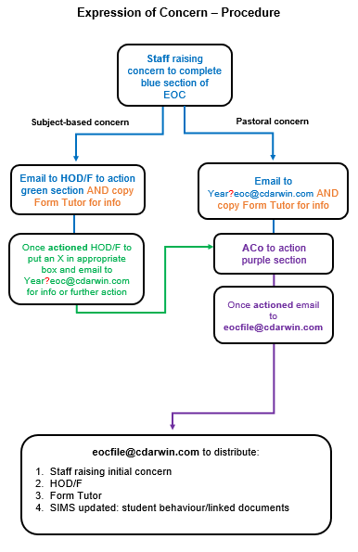

**­**

Once the EOC has been actioned, the ACo/Pastoral Manager will forward the EOC to [eocfile@cdarwin.com](mailto:eocfile@cdarwin.com) for it to be entered onto SIMS by Student Services to create a behaviour log. The EOC will be saved as a Linked document to the student concerned and a copy of the EOC will be emailed to the member of staff raising the initial concern, HOD/F and Form Tutor.

Please remember that an EOC may need to be completed, even if a Whole School Detention is set for behaviour they are essential for patterns of behaviour and may trigger conversations with HOFs/ACos.

The EOC template can be found on the staff shared area.

**All incidents of Bullying, Racism, Homophobic comments and Sexual Harassment must be logged as well as being recorded on an EOC by the member of staff who deals with them.**

**Bullying and Homophobic comments on the Bullying Log on the staff shared area and Racist Comments and Sexual Harassment via Mrs Stephens.**

**Expression of Concern Template can be found in the staff shared area under the following folder:**

**T:\Staff Resources\Expression of Concern**

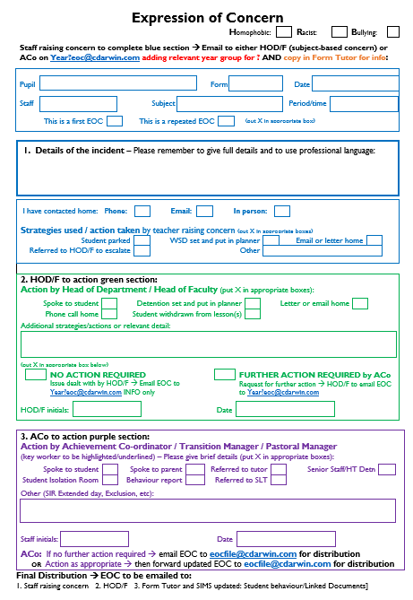

**Annex 1**

School Sanction System

**Detention System**

|  |  |  |  |  |
| --- | --- | --- | --- | --- |
|  | **Duration** | Examples of reasons | Day/time/place | **Action Required - Gatekeeper** |
| **Behaviour Points**  **(1 Behaviour Point)** | **n/a** | * No homework by deadline * Uniform infringement (tutor) and chewing gum * Repeatedly no equipment * Low level disruption after warning * Repeatedly late to lesson (twice) * Corridor behaviour | * Logged on Satchel One | * Teacher adds Behaviour Points via Satchel One. |
| **Lunch time detentions in designated areas**  **(1 Behaviour Point)** | **20-40 mins** | **Directed by ACo’s only for:**   * Uniform (No tie, trainers, no blazer) * Poor grade on ACo/SLT report * General pastoral concern | * Every day (Years 7–11) * Lunch time * Designated area, ie, SIR | * Book in detention via diary in Student Services. * Supervising ACo enters detention onto SIMS at start of detention - Behaviour Point. * Note in planner. |
| **Whole School Detentions**  **(Years 7-11)**  ***To be recorded in***  ***Student planners.***  ***Must be set by end of Period 4***  ***if required for next day due to Call Parent being sent at 1:00pm***  **(24hrs notice required)**  **(2 Behaviour Points)** | **40mins** | * Rude and defiant behaviour * Persistent Low Level Disruption * Repeated failure to complete homework**. If a pupil misses a homework deadline twice they receive a WSD. Staff must not set a WSD as a threat to get homework in**. * Repeated lack of equipment or kit. * Persistent lateness to lessons. | * Every day apart from Tuesday * From 3:00pm onwards   Register outside room with Pastoral Manager:  **- Year 7 - room LA4**  **- Year 8 - room MA3 (JHa)**  **- Year 9 - room IT3 (JHa)**  **- Year 10 - room VQ4 (JGa)**  **- Year 11 - room IT1 (SLT)**  Hard copy of registers to then be passed to supervising staff. These must then be brought to Lead SLT at the end of detention for collation**.** | * **Subject teacher to record WSD in student planner – reason/date/staff** * Subject teacher to record setting a detention on SIMS. * Tutors to remind pupils of daily WSD (names red on pm register). * P.5 teachers to escort pupils to WSD at end of day if requested. * Supervising teacher to record attendance on SIMS at start of WSD. * Tracking sheet to ACo’s on monthly basis for monitoring. * JSs to be notified of WSD absence to send Call Parent before 4pm * All registers from WSD must be left in SIR after detention. |
| * **Poor behaviour outside of school** | Corridor behaviour:   * Member of staff to give a Behaviour Point or EOC considered. |
| **Whole School Detention – 2nd attempt**  **(Years 7-11)**  **(2 Behaviour Points)** | **1hr 15mins** | * Failure to attend WSD without authorisation * Sent out of WSD for communicating/misconduct | * With SLT Team leader | * If pupil sent out, SLT Team Leader to clearly indicate this on register to enable escalation. * SLT Team leader to remain behind after normal WSD with 1hr 15mins and 1hr 15mins pupils. |

**Detention System**

|  |  |  |  |  |
| --- | --- | --- | --- | --- |
| **Type** | **Duration** | **Examples of reasons** | **Day/time/place** | **Action Required - Gatekeeper** |
| **Senior Staff Detention**  **(Years 7-11)**  **(3 Behaviour Points)** | 1hr 15mins | * Missing 2 x WSD (Years 7-11) * Aggressive behaviour * Anti-social behaviour to and from school * Smoking/vaping in uniform * Repeated poor behaviour in lesson (HOD/F) * Lesson truancy * Repeated breach of Mobile Phone policy | Set Monday/Wednesday/Friday  With SLT Team leader | * HoF/ACo to email NKa and cc SLT attached to year group with details setting/awareness of SSD and email home via main office * HoF/ACo – calls home, Detention taken by member of SLT Team leader. * (1hr 15m)   **All registers from WSD must be left in the SIR after detention.** |
| **Whole School Detentions – Year 12**  **(2 Behaviour Points)** | 40mins – 1hr30mins | * Persistent lateness to school * Truancy – lesson (30mins) * Missing key deadline (30mins) | Year 12 – IT1 | * Form tutor to monitor and set WSD on SIMS. * Form tutor to inform student of WSD date. * RKe to monitor attendance to WSD. |
| **Sixth Form Detentions – Year 13**  **(2 Behaviour Points)** | 40mins – 1hr15mins | * Teaching staff detain pupils for concerns over students work | am or pm / classrooms | * This can be set without warning, Staff to EOC HOD/F and RKe/RGo. |
| 40mins to 1hr 30mins | * Tutors set 40mins–1hr10mins for persistent lateness or truancy * HOD/HOF to inform RKe to set detention for missing department detention or persistent work problems. | Hub | * HOD/F to inform home via NMi and letter and EOC NMi/RGo. |
| **Headteacher Detention**  **(4 Behaviour Points)** | 1hr 30mins | * Missing 2 x Senior Staff detention * Day truancy * Persistent WSD’s (12+) * Serious breaches of school discipline including graffiti. * Behaviour on bus to and from school * Persistent breach of Mobile Phone policy. | Tuesday  3:00-4:30pm  Meetings Room | * ACo to email JSS and cc SLT attached to year group with details of Headteacher’s detention. * Letter home via main office and Call-Parent sent. * Detention to be taken by HT with SLT as reserve**.** |

**Class detentions should be avoided**

**Suspension & Exclusion System**

|  |  |  |  |
| --- | --- | --- | --- |
| **Type** | **Examples of reasons** | **Day / time / place** | **Action Required - Gatekeeper** |
| **Extended**  **Day Suspension**  **(5 Behaviour Points)** | * Physical aggression towards a peer (first time) * Swearing in front of a member of staff * Punching a student in the stomach * Refusal to comply with Mobile Phone policy to an SLT of staff | 8:30am – 4:00pm  SLT corridor | * Internal suspension to be discussed with either LRe, MBo or ASm before any action is taken. * Internal referral form to be completed (collected from JSs) with all details/wording checked prior to the internal suspension, along with copies of statements, if applicable. * Two copies of the letter will be prepared for ASm to sign. One copy for ASm to hand over to the student at 3:00pm and one for DRo records. A copy of the letter will be emailed home by JSs. * JSs to send notification email sent to TDa, NFr, Main Reception, Student Isolation Manager, DRo, form tutor relevant ACo, SLT and Pastoral Manager. * Main reception to meet student then direct them to SLT corridor by 8:30am to take and store mobile phone and ensure they are aware of expectations. * Readmission meeting to take place with parent, student and ACo before student returns to lessons. SLT to be invited if required. * Green readmission contract to be completed and left with JSs who will copy and return. |
| **Fixed Term Suspension**  **(5 Behaviour Points)** | * Persistent defiance of the school rules * Physical aggression towards another student * Swearing at a member of staff * Deliberately setting off the fire alarm during the school day | Off site at home  To remain out of  public places from 8:30am – 3:00pm | * Option of Fixed Term / Repeated Fixed Term suspension to be discussed with either LRe, MBo or ASm before any action is taken. This to ensure consistency of number of days. * Exclusion referral form to be completed (collected from DRo) with all details/wording checked, along with copies of statements. * Two copies of the letter will be prepared for ASm to sign. One copy for ASm to hand over to the student at 3:00pm (letter contains details of appropriate work to be completed whilst the student is excluded) and one for DRo records. A copy of the letter will be emailed home by DRo. * DRo to send notification email Main Reception, EWO, Youth Policing Team, LCl, SLT, Chair of Governors, Student Isolation Manager, NFr, JSs, TFr, Form Tutor, ACo, and Pastoral Manager. In the case of a LAC the Social Worker and Head of Virtual School to also be notified. * Readmission meeting to take place with parent, student, relevant ACo and SLT before student returns to lessons.      * Trial move to another school explored for repeated Fixed Term Suspensions. * Green readmission contract to be completed and left with JSs who will copy and return. |
| **Repeated Fixed Term Suspension**  **(5 Behaviour Points)** | * Repeated defiance and aggression as above * Disrespectful and intimidating behaviour towards staff and persistent disruptive behaviour * Repeated persistent refusal to the follow school rules and behaviour policy | Off site at home  To remain out of public places from 8:30am – 3:00pm |
| **Pending Permanent or Permanent Exclusion** | * Serious and/or persistent breaches of the School Behaviour Policy and expectations. * Threatening a student with a knife and/or bringing an offensive or replica weapon onto school premises. | Off site at home To remain out of public places from 8:30am – 3:00pm  Or  Alternative provision from sixth day | * 5 day pending permanent exclusion initially issued by ASm. * Two copies of the letter will be prepared for ASm to sign. One copy for ASm to hand over to the student at 3:00pm (letter contains details of appropriate work to be completed whilst the student is excluded) and one for DRo records. A copy of the letter will be emailed home by DRo. * DRo to send notification email Main Reception, EWO, Youth Policing Team, LCl, SLT, Chair of Governors, Student Isolation Manager, NFr, JSs, TFr, Form Tutor, ACo, and Pastoral Manager. In the case of a LAC the Social Worker and Head of Virtual School to be also be notified. * Parents to meet with ASm to discuss exclusion within 5 school days. * Pupil Disciplinary Meeting held within 15 days to allow Governors to hear parental case against the exclusion. * Final decision made by school Governors and option to appeal school’s decision given. |

**Annex 2**

SLANT, STEPS, SPACE

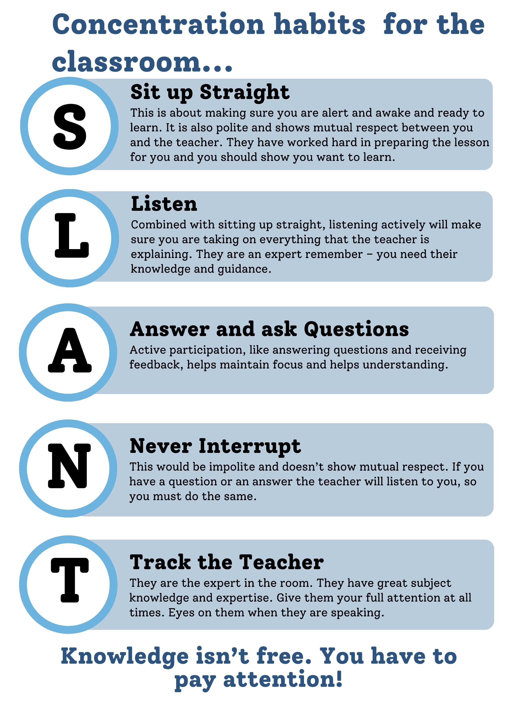

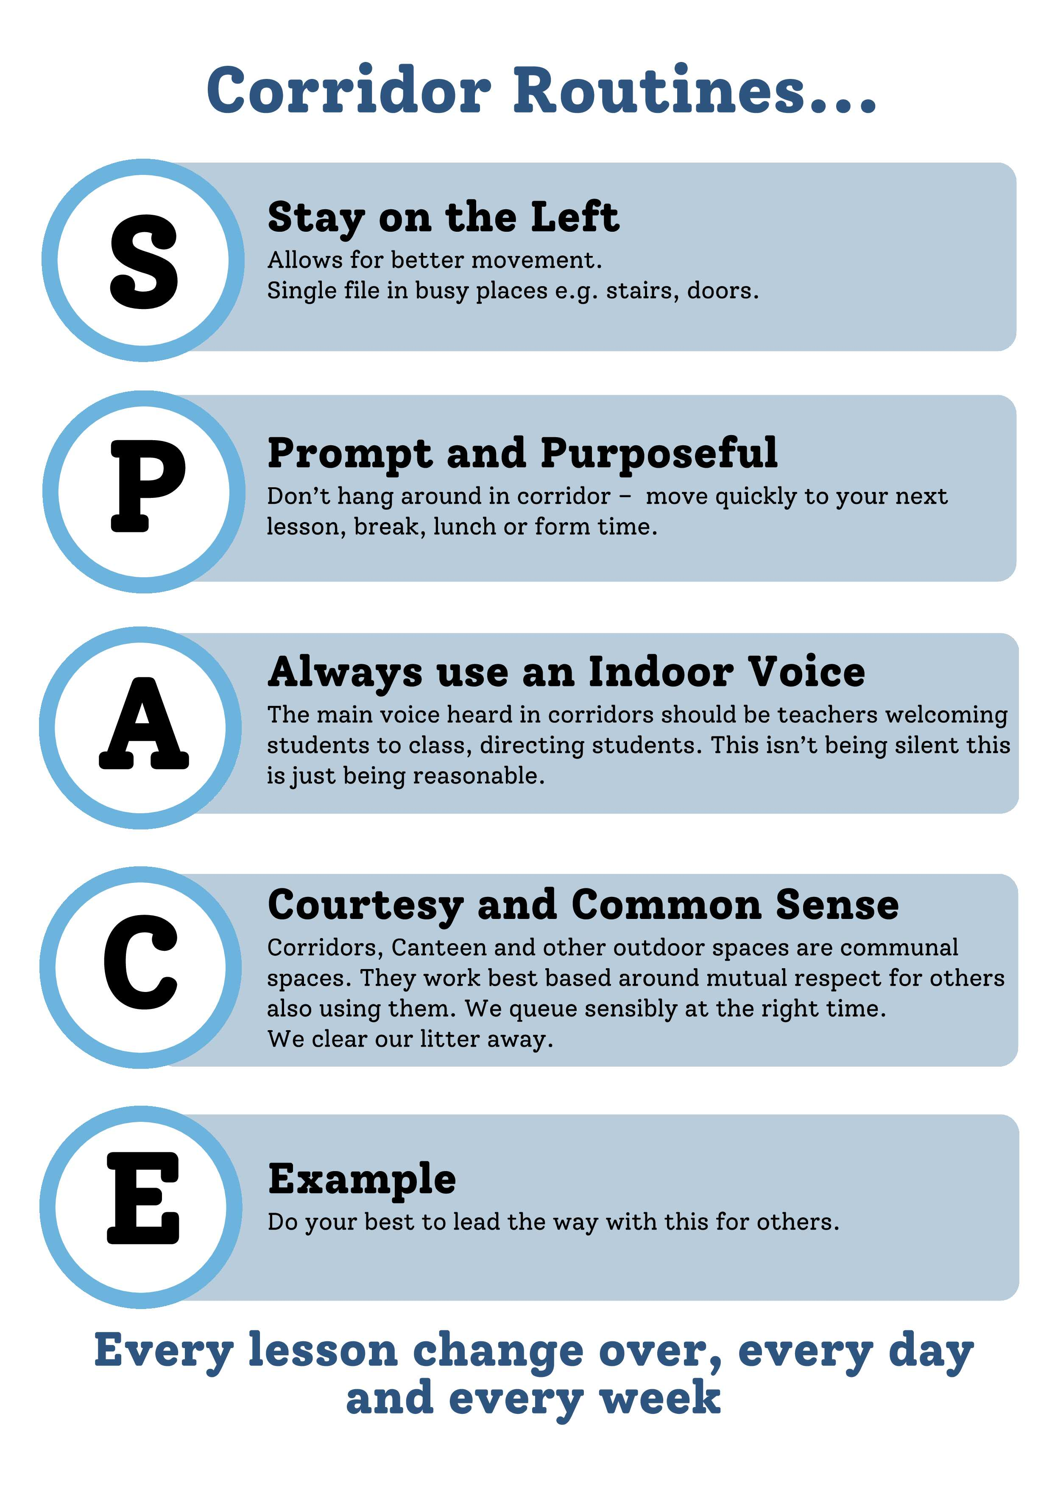

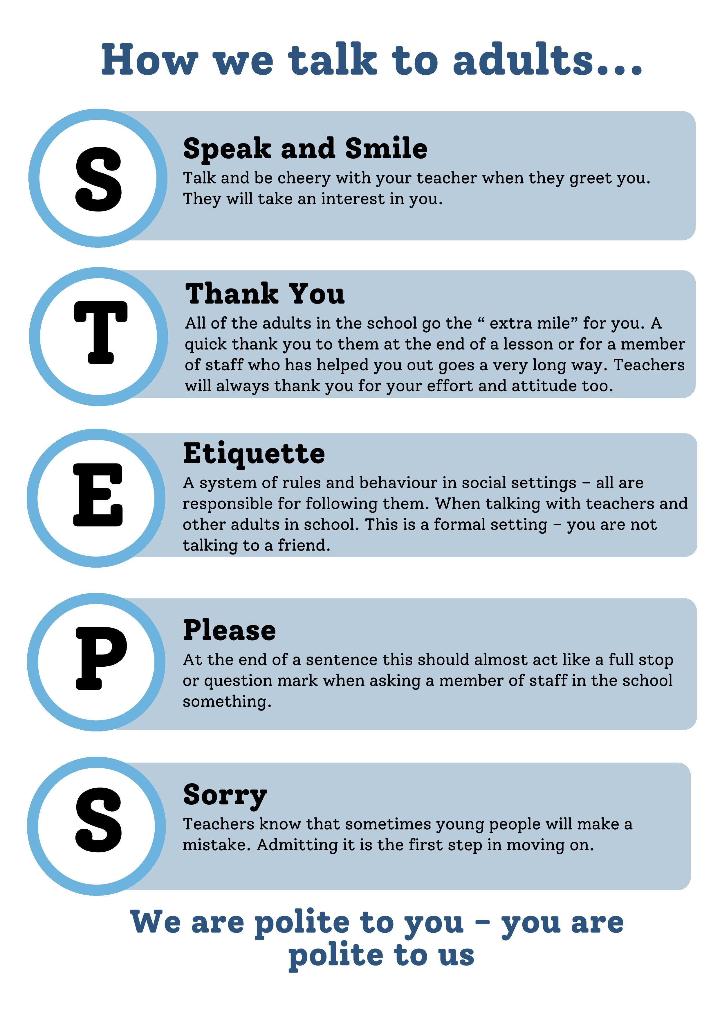

**Annex 3**Sections 3-6 of   
Suspension and Permanent Exclusion from maintained schools, academies and PRU’s in England May 2023 including pupil movement July 2022. P11 to P32 (inc).

 