Zanzibar – July 2018
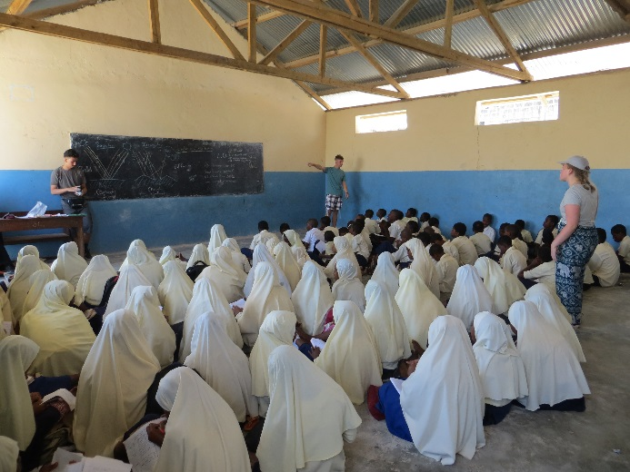
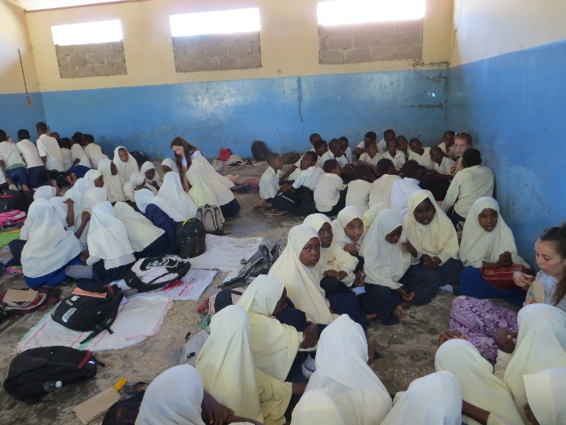
Charles Darwin School has a successful partnership with a school in Zanzibar, Tanzania called Kijito Upele. The school has two halves, each attending for either the early day or the late day and each containing 3000 students in classes of 100-130 students. Classrooms are simple and don’t have tables or chairs, and resources are scarce due to the open and unsecured nature of the site.
We work with the school to support them in making improvements to their buildings, resources and teaching and year 12 students from Charles Darwin School have the opportunity to visit in July each year.
In July 2018, 20 students had the opportunity to explore Zanzibar and, with the support of Miss Candy, Miss Sales and Mr T Jones, were involved in the teaching of science, English, maths and geography, coaching sports, or renovating classrooms in the school. The trip was definitely a case of work hard, play hard, as students prepared lessons until 9.30pm, and got up early to start a full teaching day in the blistering heat.
During our down time we visited beaches, had a tour of Stone town and a spice farm, went to a night market, and enjoyed games each evening at the youth hostel. After our week of teaching, we headed out to an eco-lodge on the coast for some much needed R & R before we returned home.
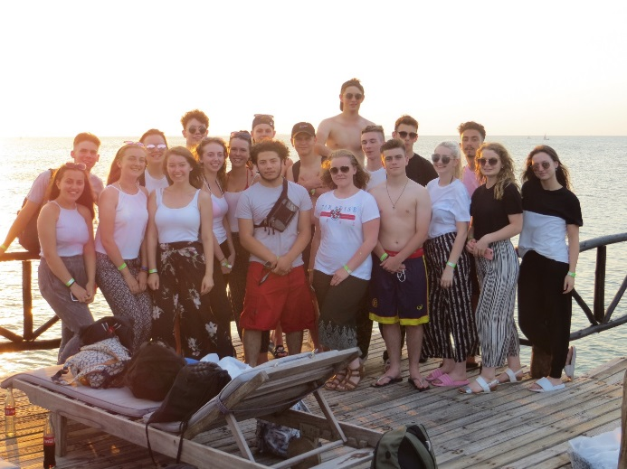
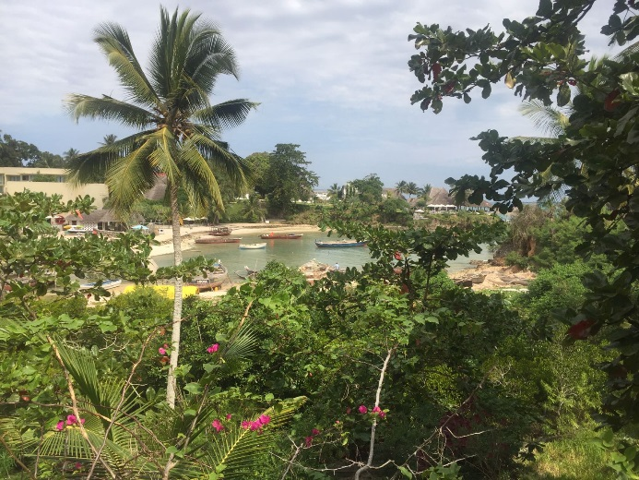
The students who attended in 2018 were required to attend planning and admin sessions; learning about food, appropriate dress, some basic Swahili and Zanzibari history and culture; though nothing could really prepare us for the realities of the spice island. It was more fascinating and more beautiful than we could have imagined.
Many students fundraised their way to Zanzibar with dedication and hard work. Some students worked Christmas jobs to fund their way, whilst others rigorously attended fundraising events such as a sponsored 18.5 mile walk from school to the Tanzanian High Commission and a mud run. Preparation sessions
As a trip, Zanzibar 2018 was hard work, exhausting, hot, challenging, life-changing, amazing, incredible and fulfilling. We are really excited to be able to continue to offer this trip to Charles Darwin Students as we continue to build on our relationship with Kijito Upele and plan our return in 2019.

